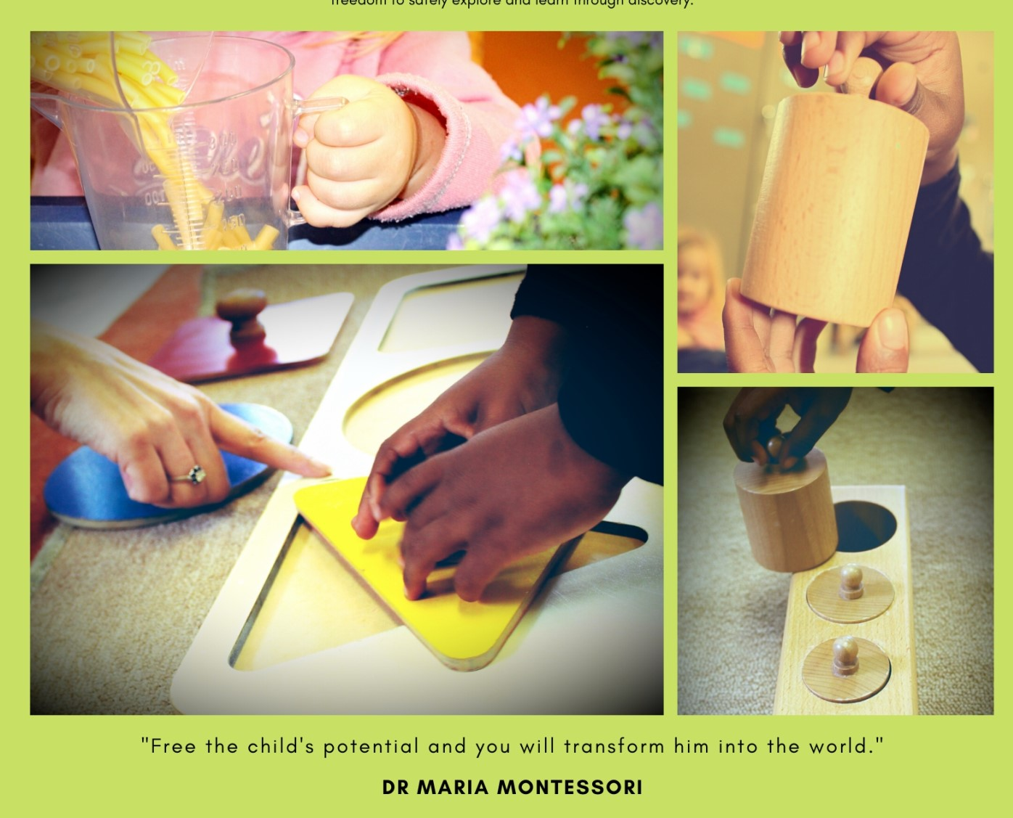 

**Toddler Phase**

**2021**

**Village Montessori School**

**Toddler Phase**

Ages: 18 months to Three years

Physical Address:

245 Glover Avenue, Lyttelton AH, Centurion

Tel: 012 664 2944

Email: [enrollments@villagemontessorischool.co.za](mailto:enrollments@villagemontessorischool.co.za)

[info@villagemontessorischool.co.za](mailto:info@villagemontessorischool.co.za)

Website: [www.villagemontessorischool.co.za](http://www.villagemontessorischool.co.za)

**Management:**

**Owner: Daleen & Nico Koen**

**Principal: Bhavna Bhagattjee**

**Our School**

Village Montessori School was established in 1992 and is registered with the Gauteng Education Department as an Independent School.

The medium of instruction is English.

**Village Montessori School Mission Statement:**

We are committed to provide a holistic education, which encourages understanding through a questioning mind.

We aim to achieve this by:

* Allowing children to develop intellectually at their own pace with the specially designed programme.
* Allowing children to develop an awareness of the environment and the importance of their role in its stewardship.
* Fostering within the children an awareness of their roles and responsibilities in society.

**The Montessori Method:**

* Dr. Maria Montessori based her education on her scientific observations of young children’s behaviour. As the first woman physician to graduate from the University of Rome and became involved with education as a doctor treating children labeled as mentally challenged.
* The basis of the education principle is that each child has an innate desire to learn. Each child learns with a unique style and pace. A holistic approach is taken where the child’s development involves many aspects: physical, cognitive, social, emotional and moral.
* The Montessori environment changes and grows with the developmental needs of the child. The materials offer concrete, multi-sensory experiences, which actively engage children, correcting, giving feedback and increasing children’s opportunities for self-directed work.

**Village Montessori Toddler Phase:**

*“The greatness of the human personality begins at the hour of birth.”*

*Maria Montessori*

Birth to Three:

*8 to 18 months: Sitters, Standers and Explorers*

*18 months to 24 months: Movers, Shakers and Players*

*24 months to 36 months: Walkers, Talkers and Pretenders*

Children learn through doing, imaging and discovering for themselves.

It is the discovery and exploration of the senses.

Cognitive Development is about the equilibrium of holistic development and the way the child explores, makes connections and communicates their new discovery.

The toddler child needs to be seen as an active learner.

The toddler child will be encouraged to develop ideas, thinking, intelligence, imagination, creativity, concentration, attention, memory, schemas and language development.

The toddler child will be developing and strengthening their Gross Motor Skills, Fine Motor Skills, Spatial Orientation, Music, Movement, Art, Emotional, Social and Cognitive Skills through various activities, songs, games, rhythms and play.

The Learning Areas also include Practical Life, Knowledge and Understanding of the World, Language and Math Development.

**Village Montessori Toddler Phase Times:**

|  |  |  |
| --- | --- | --- |
| Morning Care | Toddler, Pre-School, Primary and High School | 07:00 |
| School Starts | Toddler, Pre-School, Primary and High School | 07:45 |
| School Closes | Toddler | 12:30 |
|  | Pre-School | 12:30 |
|  | Junior Primary | 13:30  13:00 (on Fridays) |
|  | Senior Primary | 14:00  13:00 (on Fridays) |
|  | High School | 15:00  13:00 (on Fridays) |
| Aftercare | Toddler, Pre-School, Primary & High School | Until 17:30 |
| Meals provided | Toddler | Breakfast, Snack & Lunch |
|  | Pre-School | Snack & Lunch |
|  | Primary & High School | Cooked Lunch can be ordered at a reasonable cost. |

*“The most effective kind of education is that a child should play amongst lovely things.”*

*Plato 427-347BC*

**Compulsory Supporting Documents:**

Please ensure that all the legally relevant documentation is submitted to the School to finalize enrolment at VMS:

* Child’s Birth Certificate
* Child’s Immunization Record/ Clinic Card
* Copy of both parents/Guardians ID documents
* Copy of Medical Aid Card
* Proof of Residence

**Updating Contact Details:**

Please ensure that your address, telephone numbers and emergency contacts are updated when any changes are made. It is your responsibility to keep this information updated, as it is vital for emergencies.

**Medication:**

* All medication must be placed in a clear plastic bag with clear instructions and handed to the teacher.
* No medication must be placed in the child’s bag.
* All allergies must be alerted to the teacher.
* All medication must be recorded in the Medicine Administration Book with clear instructions.
* No medicine will be administered to your child without your written signed permission.

**Sick Children:**

No child may attend the school if he/she has:

* Any contagious/infectious illness
* Diarrhoea in the past 24 hours
* Vomited in the past 24 hours
* Temperature above 37.8.
* A rash; infected eyes
* Septic focus
* Lice/nits
* Heavy cold or cough

**Village Montessori Toddler Phase Requirements:**

All the requirements must be brought to school in the first week of school, in a plastic bag, clearly labeled.

All your child’s clothing and belongings need to be clearly labeled.

* A small school bag which your child can pull/carry and open themselves. It must be clearly labeled.
* Two dark colour face cloths with loops attached, clearly marked with the child’s name.
* Hair brush/comb; clearly labeled
* A plastic Art apron
* Three sets of a full change of clothing (according to the season)
* A plastic bag (in case of emergencies for toilet accidents)
* A sun-hat is compulsory; clearly labeled which will stay at school.
* A blanket for nap time clearly labeled
* A pillow for nap time, clearly labeled
* Sunblock
* 1x soft tissues
* 1x Dettol Hand Wash
* A 92 page A5 hardcover book
* A 20 page Flip File
* A4 Plastic pouch with press stud for notices/messages/art work
* 2x Pritt
* 1x ponal glue
* Water bottle
* Children who are not potty trained will need a **daily** supply of nappies, barrier cream/powder and wetwipes
* Children need to be dressed comfortably for the activities of the day.
* Tights must be worn under skirts/dresses.
* No high heels or jewelry is allowed.
* No make-up or fancy dress or character costumes/t-shirts may be worn at VMS. Eg. Superman

**Toddler Phase Application Process**

We are selective when it comes to admitting students because the groups are small and we need to ensure that the appropriate atmosphere of learning and respect is maintained at all times.

For any potential pupil to be considered we must receive a completed application form accompanied by a copy of the most recent therapy, relevant medical or professional reports and recommendations where applicable. We cannot proceed with the application until we receive your forms. Parents are strongly advised to submit the application form as early as possible because enrolment date is a factor in establishing priority in the event of a shortage of places. Young children may be placed on the waiting list. It is important that younger siblings are also enrolled as soon as possible.

Parents will be notified in writing of the results of their child’s application as well as the commencement date, and are asked to notify the school either verbally or in writing of their intention to accept the place. Before your child may be enrolled the registration fee and first month school fee is payable within the time stipulated to secure their place in the school. Should the child be accepted, parents will also be invited for a parent interview. The interview is held with both parents/caregivers, the Village Montessori Enrolment Committee and the Principal. This is a platform for both sides to explore expectations and suitability. The Enrolment Committee considers a number of factors but the key considerations are the suitability of the child to the Montessori environment, level of family commitment to the Montessori Method, welfare of the school and smooth transition for the child.

**Family Commitment**

All primary caregivers should attend a parent interview as Montessori education is most effective when a child’s caregivers understand and co-operate with the long-term programme.

Parents and caregivers need to show understanding of the Montessori philosophy of teaching and fully support its methods. They need to agree to support the VMS staff. Parents and caregivers need to be willing participants and fully support all initiatives of the school in fundraising ventures, working days, parent education evenings, equipment making and social events. We are very happy for parents to indicate their own particular skills and preference for areas they would like to assist with.

**Toddler Phase Application Process**

We are selective when it comes to admitting students because the groups are small and we need to ensure that the appropriate atmosphere of learning and respect is maintained at all times.

For any potential pupil to be considered we must receive a completed application form accompanied by a copy of the most recent therapy, relevant medical or professional reports and recommendations where applicable. We cannot proceed with the application until we receive your forms. Parents are strongly advised to submit the application form as early as possible because enrolment date is a factor in establishing priority in the event of a shortage of places. Young children may be placed on the waiting list. It is important that younger siblings are also enrolled as soon as possible.

Parents will be notified in writing of the results of their child’s application as well as the commencement date, and are asked to notify the school either verbally or in writing of their intention to accept the place. Before your child may be enrolled the good faith deposit, registration fee and first month school fee is payable within the time stipulated to secure their place in the school. Should the child be accepted, parents will also be invited for a parent interview. The interview is held with both parents/caregivers, the Village Montessori Enrolment Committee and the Principal. This is a platform for both sides to explore expectations and suitability. The Enrolment Committee considers a number of factors but the key considerations are the suitability of the child to the Montessori environment, level of family commitment to the Montessori Method, welfare of the school and smooth transition for the child.

**Family Commitment**

All primary caregivers should attend a parent interview as Montessori education is most effective when a child’s caregivers understand and co-operate with the long-term programme.

Parents and caregivers need to show understanding of the Montessori philosophy of teaching and fully support its methods. They need to agree to support the VMS staff. Parents and caregivers need to be willing participants and fully support all initiatives of the school in fundraising ventures, working days, parent education evenings, equipment making and social events. We are very happy for parents to indicate their own particular skills and preference for areas they would like to assist with.

**Toddler Phase School Fee Structure for 2021**

Enrolling a child at VMS represents a significant financial investment for the average family. Our families are very special people who recognize and appreciate that an investment in education truly pays the best dividends.

Our fees are calculated as one child’s share of the annual operational expenses, therefore it is essential that our annual income be assured by the timely payment of fees by parents.

**Good Faith Deposit: R9 000-00**

**Registration Fee: R 500.00**

**Fee per Month: R3 200.00 (x 11) for full day**

This Fee includes: Aftercare up to 17:30, Clamber Club, Breakfast, Snack & Lunch

The Good Faith Deposit is required in advance upon successful application to secure your child’s place. The deposit will be adjusted whenever a child moves up from one phase to the next, in other words to Pre-School, Junior Primary, Senior Primary and High School.

The deposit, or the balance of the deposit after the deduction of outstanding amounts, will be refunded after termination of enrolment. In terms of the Enrolment contract signed by parents, a term’s written notice must be given in order for the deposit to be refunded. Parents, whose children leave at the end of the year, will be refunded at the end of January the following year.

**Banking Details:**

**Nedbank** Centurion

Branch no: 162-145

Account no: 1621 138 658

Cheque (Current) account

Name: **Village Montessori School**

Please use child’s name and surname as a reference.

Proof of payment can be e-mailed to: daleen@villagemontessorischool.co.za

**SCHOOL CALENDAR 2021**

**TERM 1**

School Opens: **Wednesday 13 January**

Mid-term School Closes: Thursday 25 February

Mid-term School Opens: Tuesday 02 March

Public Holiday: Monday 22 March 21, Human Rights Day

Good Friday: Friday 02 April

Family Day: Monday 05 April

School Closes: **Wednesday 14 April** 11:00

**TERM 2**

School Opens: **Wednesday 05 May**

Mid-term School Closes: Friday 11 June

Mid-term School Opens: Monday 21 June

School Closes: **Friday 06 August** 11:00

**TERM 3**

School Opens: **Tuesday 07 September**

Public Holiday: Friday 24 September Heritage Day

Mid-term School Closes: Thursday 21 October

Mid-term School Opens Tuesday 26 October

School Closes: **Friday 03 December** 11:00

**Please note:**

**NO HOLIDAY CARE AVAILABLE**

**VMS FOOD AND NUTRITION POLICY:**

**RATIONALE**

There is now clear evidence that a wide variety of colourants, preservatives and additives in food may be harmful, especially to children. Food containing these substances are not allowed at school.

Due to the fact that controlling sharing is very difficult, the School has a strict food and nutrition policy. Food containing these substances is not allowed at school.

**NOT ALLOWED:**

E621 MSG Flavour Enhancer, E622 Monosodium glutamate, E102 Tartrazine,E129 Allura red, E133 Brilliant Blue, E951 Aspartame, E220 Sulphur Dioxide

These are found in some chips, cool drinks, Fizzy drinks, chocolates, sweets, marshmallows, Niknaks, Fizzers, Jelly Tots, frozen and fast foods, soups and stock.

**SUGGESTED TREATS for Birthdays:**

Lays Chips (Lightly salted)

Popcorn (Homemade)

Kit Kat, Aero, Milo Bars

Muffins, Cupcakes (Vanilla or Chocolate icing)

Marshmallows (Only White)

The School is a **NUT-FREE Zone** due to allergies.

Please ask a Teacher or the Principal if you are not sure.

**VMS Toddler Phase Disciplinary Policy:**

Maria Montessori developed the concept of “normalisation” to describe the process by which each child acquires certain personality characteristics that lead to success in the classroom and throughout life. A “normalised” child will love learning, be kind to others, develop concentration and good work habits and become independent.

Our goal is to create and maintain an environment in which each child can successfully reach this level of normalisation. Many discipline problems can be avoided by the following proactive strategies practised in every VMS classroom.

Basic rules are explained to the children. They are reminded if they break the rule for the first time. The teacher will demonstrate the correct way to act or do. The child will be gently removed if they are hurting others.

Discussions are vital with the parents. The parents will be informed and the children will be assisted in the most loving manner.

The Principal will talk to the child/parent if needed. Intervention from an Educational psychologist may be suggested to support the needs of the child.

It is important that the parents understand the Montessori Philosophy and apply the same philosophy of discipline at home. This is most beneficial for the holistic development of the child.