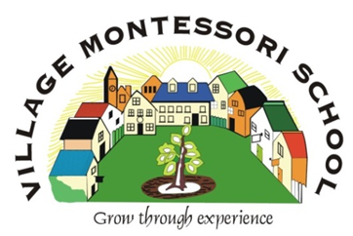
VMS HIGH SCHOOL

2022 Brochure

BROCHURE 2022

245 Glover Ave, Lyttelton AH, Centurion
info@villagemontessorischool.co.za
www.villagemontessorischool.comm

Tel: 012 664 2944 Fax: 012 664 6681

el: 012 664 2944 Fax: 012 664 6681

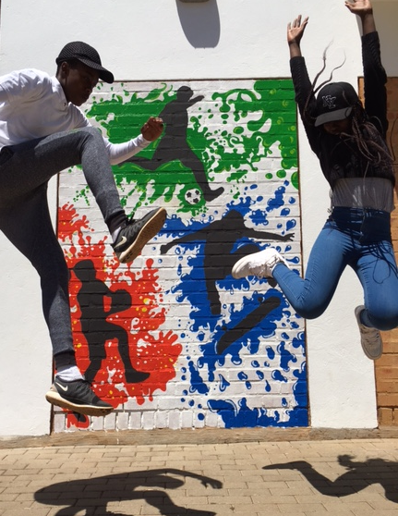

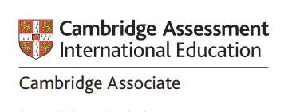

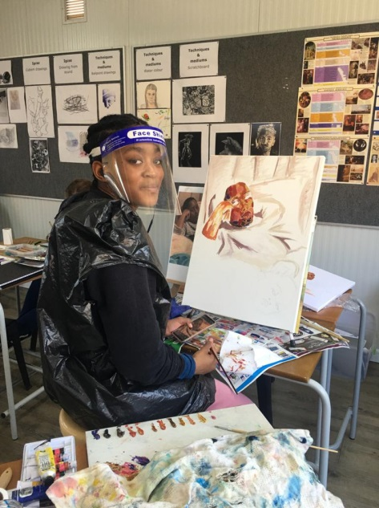
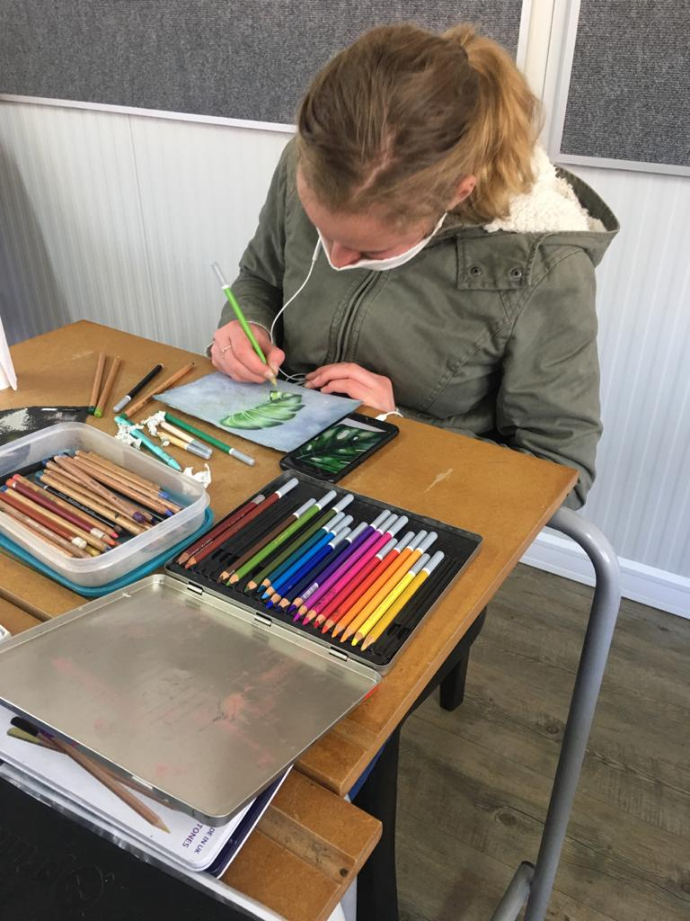
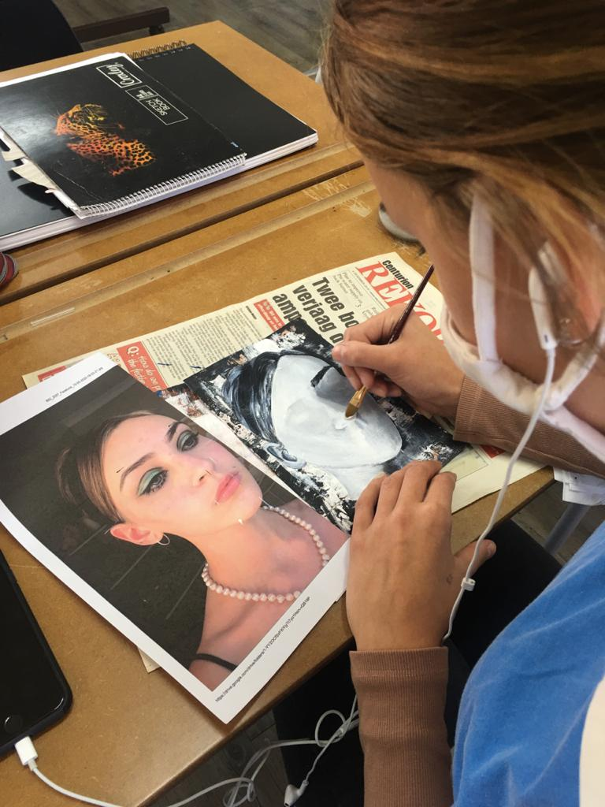

Table of Contents
Our School | 3
Why Cambridge? | 5
Outstanding Cambridge Awards | 6
High School Phases | 7
Subject Choices | 8
Recognition of cambridge qualifications by USAF | 9
Drama and Art | 10
General information | 11
Application process | 12
School Fees for 2022 | 13
School Terms for 2022 | 14
High School Policies | 15
VMS High School of choice | 21

OUR SCHOOL
The Village Montessori Pre-, Primary- and High School was established in 1992 and is registered with the Gauteng Education Department as an Independent School.
The Examination Body for our High School is Cambridge Assessment International Education.
OUR METHOD
The School is based on the Montessori principles as compiled by Maria Montessori, a well-known Italian educator. The basis of the method is the viewpoint that each child has an innate desire to learn. Therefore, the prerequisite to learning is a prepared environment where the child can be directed and not taught.
Our High School students follow the Cambridge University International Curriculum from year 7 to 12. Children are allowed to study at their own pace and in a self-directed manner. The year 7 students are included in the High School as their needs differ from those in Senior Primary. The division at this phase is consistent with the Montessori philosophy, where adolescents are grouped according to ages, i.e. 12-15-year-olds and 15-18-year-olds. Each grouping has different needs, requiring different approaches.
Montessori education at the Secondary level has great relevance in our modern world. Traditional high schools prepare students for further studies: they do not concentrate to the same degree on guiding young people to independence and adapt to social life. On the other hand, Montessori education not only prepares adolescents to take their place in working society as adults, but it also continually prepares them to be well-grounded and confident.
Adolescence is that period in an individual's life during the difficult transition from childhood to adulthood. Adolescents have problems, situations, needs and interests that are particular to them only. Students at this stage of their development have to cope with puberty, newfound sexuality and untapped creativity
The objective of our High School is to meet the academic and social needs and interests of the adolescent: specific consideration and allowance must be made for their beginning steps towards independence, making their own decisions, identifying themselves with others, rapid growth, and the possible lack of harmony - physically, mentally and in social relationships.
Our education goals try to include preparation for present-day and future living, adaptability to change, development of citizenship, development of self-discipline and development of personal and social goals.
In keeping with the above, Village Montessori High school aims to:
- encourage students to question;
- recognise individual differences;
- be facilitators of learning;
- allow students to progress at their own rate;
- enable students' own work time;
- develop planning and problem-solving skills;
- teach communication skills;
- develop self-understanding;
- stimulate personal creativity.
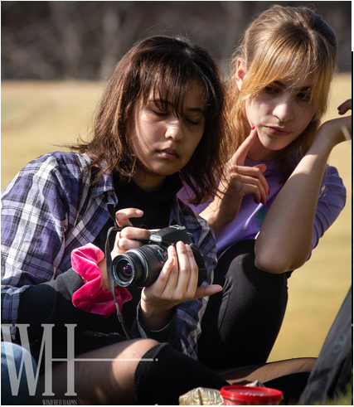

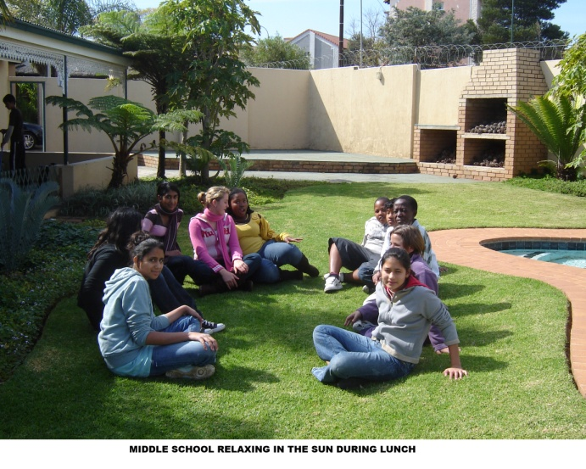

WHY CAMBRIDGE?
CAMBRIDGE LEARNERS ARE:
CONFIDENT
RESPONSIBLE
REFLECTIVE
INNOVATIVE
ENGAGED
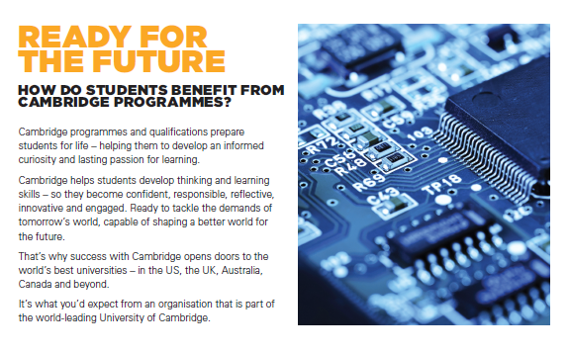

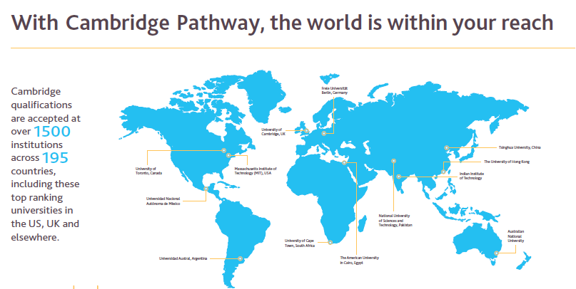

OUTSTANDING CAMBRIDGE LEARNER AWARDS
Outstanding Cambridge Learner Awards are a group of awards issued by Cambridge Assessment International Education. They recognise exceptional learner achievement in Cambridge examinations around the world. The primary purpose of these awards is to celebrate and recognise the success of high-performing Cambridge learners.
VMS STUDENTS WHO RECEIVED AWARDS:
- Ameer Mohamed November 2019: Top in South Africa: AS Marine Science.
- Thato Modibane November 2017: Top in the World: AS Mathematics
- Taahir Mohamed November 2017: Top in South Africa: AS Marine Science
- Keara Stapelberg November 2016: Top in South Africa: AS Business

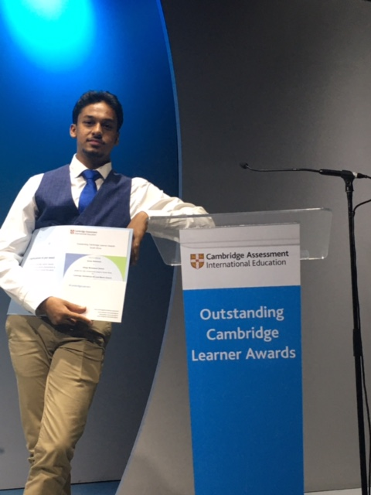

Ameer Mohammed: 2019

HIGH SCHOOL PHASES

BRITISH COUNCIL ASSOCIATE
We are an Associate centre of the British Council. Cambridge International Assessment Education is the only exam board wholly owned by a world-leading university, the University of Cambridge. We begin the Cambridge curriculum in year 7. Therefore, we align ourselves with the British timeline for completing these studies.
Unlike schools with a more traditional approach, students work in a more self-directed manner and are allowed to pace themselves. We want each student to fulfil their potential and make the most of their best subjects. The Cambridge programmes are flexible, and a student can accelerate within a phase. As a result, learners are prepared for University and learns to take responsibility for their work and achievements at a young age.
PHASES
FOUNDATION PHASE – (Grade 7 and 8)
The Foundation phase is a minimum two-year program designed to give students a firm grounding in the concepts of Mathematics, Natural Sciences (Biology, Physics and Chemistry) and English. In addition to these core subjects, we also offer Afrikaans, French, Social Science (History and Geography), Economic Management/Accounting, Art and Design and Computer Literacy. The students write internal examinations.
IGCSE PHASE – (Grade 9 and 10)
The International General Certificate of Secondary Education (IGCSE) is an international qualification that has been designed to equip students with the skills needed for immediate employment. The IGCSE phase provides a comprehensive study programme by drawing subjects from five areas: Languages, Humanities, Mathematics, Creative, Technical and Vocational. Within the curriculum, there is a balanced mix of practical experience and theoretical knowledge. This course is equivalent to the British GCSE or O levels, and the students write external exams which University of Cambridge Assessment International Education marks. Students complete this phase over two years.
AS-LEVEL (Grade 11 and 12)
The AS-Level is the first stage of A-levels and is equivalent to years 11 and 12 of South African schooling. Due to the high academic level required, students will complete the AS-level over 18 months to two years. A-level is not offered at our School.

A-LEVEL (Post Matric)
English First Language, Mathematics and Computer Science are offered on the A-level. The A-Level is a post-matric qualification and can be done in the same year as the AS-level or an additional 6 months after the AS-level is completed.

SUBJECT CHOICES

INTERNATIONAL GENERAL CERTIFICATE OF SECONDARY EDUCATION [IGCSE]

Students take a minimum of seven subjects:

COMPULSORY SUBJECTS:
- English First Language
- Afrikaans Second Language AND/OR French Foreign Language
- Mathematics

THE REMAINDER OF SUBJECTS ARE SELECTED FROM THE FOLLOWING:

- French

- Chemistry

- Physics

- Biology

- Business Studies

- Accounting

- Economics

- Travel and Tourism

- Art and Design

- Computer Science

ADVANCED SUBSIDIARY [AS] LEVEL
Students take a minimum of 5 subjects to obtain an equivalent to a senior certificate with exemption. One subject may be an igcse subject with a minimum "c" symbol.

COMPULSORY SUBJECTS:
- English First Language

- Mathematics

THE REMAINDER OF SUBJECTS ARE SELECTED FROM THE FOLLOWING:

- Afrikaans Second Language

- French Foreign Language

- Physics

- Chemistry

- Biology

- Economics

- Accounting

- Business studies

- Art and design

- Computer Science

- A-LEVEL (Pre-university level)

- English Frist Language
- Mathematics
- Computer Science

RECOGNITION OF QUALIFICATION BY UNIVERSITIES SOUTH AFRICA(USAF)

- For South African university entrance (exemption), a student is required to pass at least five different subjects from the correct subject groupings of which:
- 5 subjects should be on the AS level
- OR four subjects on the AS level and one on the IGCSE level (C)
- OR 2 subjects at A-Level PLUS 3 subjects at IGCSE Level (C)
- English on the AS level should be a first language, passed with a minimum of a D symbol;
- At least two are language subjects, one being the first language;
- For University admission, candidates must achieve A-Level (A-E grades), AS-Level (A-D grades; and IGCSE level (A–C grades).
- Students will need to satisfy all of these requirements over a period of not more than two (2) exam sittings (2 years).
- To obtain a Senior Certificate (non-university entrance), SAQA requires: A total of five subjects, including three IGCSE grades A–C plus two passes at AS Level grades A –D; OR
- A total of seven subjects, including five IGCSE subjects grades A – E plus two passes at AS Level grades A–D;
- Each of these combinations must include English as a first language.

For entry requirements to a specific University, University of technology or College in South Africa or abroad, students must confirm with the institution of their choice. To find the admission requirements online for South African universities, students should look at the 'international' admission requirements in each University's admission documents.

DRAMA AND ART
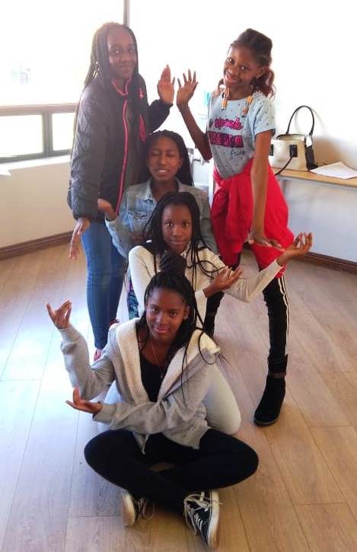

DRAMA AND ART are integrated into the school day. Drama and Art are compulsory for the Foundation Phase students. The approach will be a combination of formalised tuition and performance classes or opportunities.
- DRAMA
Lessons are geared towards building self-confidence and stage presence and will include the following aspects: acting skills, characterisation, mime, make-up, dance, stage confidence and voice projection.

B. ART & DESIGN:
All Foundation phase school students take Art as a subject. At the IGCSE and AS levels, students can choose Art and Design as a subject. It is recognised for exemption purposes.

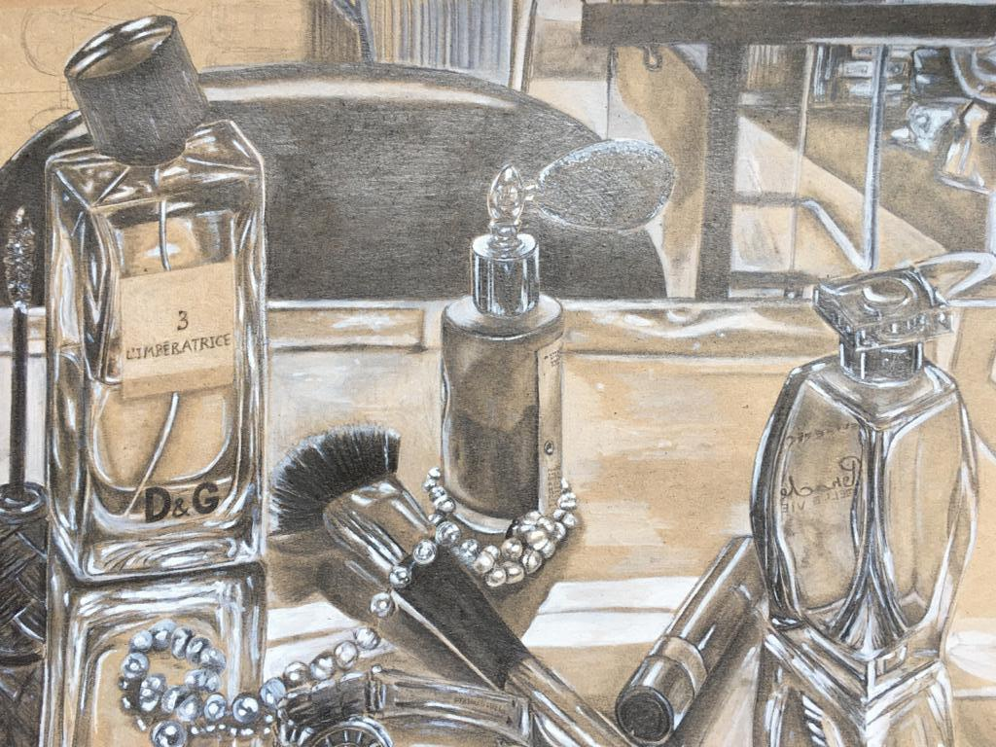

GENERAL INFORMATION
FOUND 1 AND 2 | Monday to Thursday | 7:45 - 14:00
IGCSE AND A-LEVEL | Monday to Thursday | 7:45 - 15:00
ALL PHASES | Friday | 7:45 - 12:30

- Tutorials start strictly at 7h45. No latecomers will be allowed to enter the classrooms and disrupt tutorials.
- Aftercare is available until 17:00. High School students pay R40 per day starting from 15:15 on weekdays and 13:15 on Fridays up to 17:00.
- A cooked lunch can be ordered at R30 per meal.
- Staff/pupil ratios: = 1:15 this is a guideline only
- We have a three-term year.
- No school uniform is prescribed. However, students have to be dressed acceptably.
- We encourage healthy eating and therefore have a strict food policy.
- A five per cent discount is granted on sibling's fees and a ten per cent discount on fees paid in full before 31 January.
- Four months' written notice is required in the event of a student leaving the School to receive a full refund of the deposit.
- Parents need to reinforce the methods used at School at home as well.

APPLICATION PROCESS
We are selective when it comes to admitting students because the groups are small, and we need to ensure that the appropriate atmosphere of learning and respect is maintained at all times. Therefore, only students with impeccable personal records will be considered. In addition, our School is committed to building a close community, and it is essential to build a relationship with the family. Therefore, our admissions process attempts to gather a picture of each applicant as complete as possible. It includes a classroom visit, an interview, an assessment of the applicant, and a review of the student's academic record.
Once the application form and report card/Cambridge Certificate are received, an invitation for an assessment will be sent to the parents. An application fee of R1 500-00 is payable before the assessment. After a successful assessment, parents will be informed and invited to an interview at the School.
High School students are expected to spend a day at the School to experience Montessori/Cambridge education for themselves before making a final decision. We also need time to ascertain whether or not the prospective student will prosper in a Montessori setting. If your child is accepted, the Good Faith Deposit is payable within the time stipulated to secure their place in the School.

HIGH SCHOOL FEES FOR 2022
FOUNDATION PHASE (GR 7 and GR 8)
Application fee: | R1 500.00 Non-Refundable
Good Faith Deposit: | R26 000.00
Monthly fee: | R 8 850.00 (X 11)
This fee includes: | School fees up to 14:00, Occupations and Academic Materials: Work programmes and textbooks.
Aftercare fee per day: | R45 from 14:15 up to 17:00 per child per day
Meals per day: | R30 per meal per child
Sibling discount: | 5% on monthly school fees
School fees paid upfront by 31 January for the year: 10% discount

CAMBRIDGE IGCSE AND AS PHASES (GR 9 - GR12)
Application fee: | R1 500.00 (Non -Refundable)
Good Faith Deposit: | R29 000.00
Monthly fee: | R10 100.00 (x 11)
This fee includes: | Tutoring fees up to 15:00, all academic materials, i.e. work programmes, textbooks and External Exam Fees
Aftercare fee per day: | R45 up to 17:00 per child
Meals per day: | R 30 per meal per child
Sibling discount: | 5% on monthly school fees
School fees paid upfront for the year by 31 January: 10% discount

Annual payment upfront carries a 10% discount if paid before 31/01/2022
Fees are payable on the 1st of the month in advance for 11 months of the year (January to November).

BANKING DETAILS
FIRST NATIONAL BANK
Branch no: 250-655
Account no: 62904723914
Cheque (Current) account
Name: Village Montessori School
Please use the child's name and surname as a reference.
Proof of payment can be emailed to: daleen@villagemontessorischool.co.za

SCHOOL TERMS 2022
TERM 1
School Opens: | Wednesday | 12 January
Mid-term School Closes: | Thursday | 24 February
Mid-term School Opens: | Tuesday | 01 March
Public Holiday: | Monday | 21 March | Human Rights Day
School Closes: | Wednesday | 13 April | 11:00

TERM 2
School Opens: | Wednesday | 04 May
Public Holiday: | Thursday | 16 June | Youth Day
School Holiday: | Friday | 17 June | School holiday
Mid-term School Closes: | Friday | 24 June
Mid-term School Opens: | Monday | 04 July
School Closes: | Friday | 05 Aug | 11:00

TERM 3
School Opens: | Tuesday | 06 September
Mid-term School Closes: | Thursday | 20 October
Mid-term School Opens: | Tuesday | 25 October
School Closes: | Wednesday | 07 December | 11:00

YEAR PLANNER
A comprehensive term planner will be sent out at the beginning of every term in the Weekly Notices.

HIGH SCHOOL POLICIES
VMS is built on the concept of a community. A community shares common values. Its members seek to give as much as they can for the good of the whole and take only what they need. The community aims to raise the level of the lowest members while keeping the entire community progressing toward a shared vision. At VMS High School, we value:
- Respect for ourselves, others and the environment;
- Honesty;
- Courtesy and exceptional manners;
- Empathy for others and respect for differences among people and cultures;
- Responsibility for personal decisions and actions;
- Cooperative work with others, which includes listening, sharing options, negotiating, compromising, helping to reach consensus, and taking a stand;
- Seeking one's share of the workload;
- Balancing the needs of individual students and families and the needs of the school population as a whole; and
- Pride in our School.

1. CELL PHONES AND TABLETS:
- High School students are allowed to bring their cell phones to School to facilitate contact with parents and educational purposes. However, it should be out of sight and switched off during academic time.
- Students are allowed to phone parents from the High School Office or their cell phones during breaks or after School.
- They are allowed to listen to music with earphones with permission from a subject teacher:
- During Art Classes
- Senior students can use earphones during Academic periods ( help them concentrate when they are busy with classwork.
- Cell phones are allowed on the premises of the High School only. Likewise, no earphones are permitted outside the High School Premises.
- Cell phones may be used for research under the supervision of subject teachers.
- Tablets and laptops are only allowed when students are busy with a research project and are requested by subject teachers to bring it to School. It will always be at the student's own risk.
- Cell phones will be confiscated if any of these privileges are abused.

2. ABSENTEEISM
Students are expected to be at School during the term unless one of the following valid reasons applies:

they are genuinely ill
- the family experienced a trauma such as a bereavement etc.;
- the student belongs to an external sports club and is required to go on tour;
- absence is motivated, and permission is granted;
Please note:
- Holidays should be arranged during the official school holidays.
- Absenteeism which occurs on a day preceding or following a weekend, long weekend, mid-term break or school holiday, or on a day a test or examination is written, requires submitting a valid sick note on the day of the student's return to School.
- The School ceases to take responsibility for a student who is absent for more than 15 school days.

3. LEAVING EARLY/DOCTOR'S APPOINTMENTS
Lucky is under strict orders not to allow students out during school time without written permission from the class teacher for security reasons. Please inform the class teacher or send a note to School should your child have a doctor's appointment, and we will gladly provide an early leaver's slip. In the case of extra murals, kindly ensure that your child's external extra murals begin after 15h00 on weekdays.

4. AFTERCARE
Aftercare begins at 15h15 and closes at 17h00. High School students pay R45 per day. High School students will join the rest of the School in aftercare from 16h00 to 17h00. High School students who are collected after 17h00 will not be accommodated in our aftercare. Parents have at times contacted Lucky directly when they are running late. Please do not contact Lucky as he is not at the gate and will not be allowed to supervise your child after 17h00. A fee of R150 per 5 minutes will be charged from 17h00 to be paid when collecting your child.

5. DRESS CODE
- Girls are allowed to wear shorts of an appropriate length.
- No underwear should be visible. This applies to boys and girls.
- Straps of tank tops are allowed to show with spaghetti strap tops
- No cleavage is permitted.
- Leggings must be worn with a long top that covers the buttocks.
- Please keep in mind that this is an Academic Environment.

6. HOME/SCHOOL COMMUNICATION
Changes in a child's home life may affect his/her behaviour and performance at School. Therefore, please notify the office and your child's classroom teacher if any significant changes occur, such as:
- Extended vacations or business trips by a close family member;
- A child staying somewhere other than at home (a relative/friend's house) for more than a day or two;
- Loss of family member, including pets;
- Moving house;
- Change in a family environment (separation, divorce, new partner, new baby);
- Serious illness or hospitalisation of a family member.
Please note that this information will be strictly confidential.

7. DISCIPLINE

BEHAVIOURAL EXPECTATIONS
In the School context, teachers, parents and pupils have responsibilities. To sustain a healthy learning environment, these parties to the education relationship must acknowledge their respective responsibilities.
The School prides itself on having good relations with the parents of pupils. However, while parents must expect the School and its teachers to provide the best education possible with the resources available to the School, parents must also accept responsibility to help the School achieve this goal.
The School recognises that every pupil does have the right to education. However, pupils themselves must also remember that they have responsibilities to their parents, the School, Teachers, fellow pupils, and themselves.
Pupils must, therefore:
- Comply with instructions and the general rules of the School.
- Behave responsibly and not endanger the safety and welfare of others;
- Respect and care for the property of the School and others;
- Maintain sound relations with others at School, be courteous and respect the dignity and self-worth of others;
- Be punctual and observe the timekeeping practices of the School;
- Demonstrate a positive attitude towards the opportunity to learn, and be diligent in their efforts to learn;
- Behave honestly and conduct themselves with integrity;
- Accept the authority of Teachers.
- Accept legitimate punishment and disciplinary action taken against them.

MANAGING/ADDRESSING POOR BEHAVIOUR: PROCESS
If a child exhibits unacceptable behaviour, the following disciplinary action will be taken, according to the severity of the misbehaviour.
- The High School's Disciplinary Code for pupils is intended as a penalty guideline for Teachers. It may be deviated from to accommodate specific circumstances.
- It indicates the maximum disciplinary action generally considered appropriate for various types of infringements and misconduct by pupils. However, the circumstances of a particular case under consideration may justify less severe action than that indicated in the Code.
- The infringements listed in the Code are not intended to be an exhaustive listing but rather an indication of the type of deviation from expected standards of conduct and the levels of severity of infringements.
- Please note that the Code provides "progressive" or accumulative penalty, i.e. the imposition of a harsher sanction for repeated misconduct in the case of less severe infringements.

DISCIPLINARY MEASURES
- VMS High School may initiate various forms of informal and formal disciplinary measures. The severity of action taken by the School will depend on circumstances, the seriousness of the infringement, and any relevant mitigating or aggravating factors.
- Therefore, the disciplinary measure or penalty applied in response to the pupil's misconduct will generally require the Teacher or Head to exercise discretion in deciding on the appropriate and fair action to be taken.
- Discipline must be feasible and effective, be applied progressively. Repeated commission of a similar or related offence will result in progressively more severe action being taken, particularly where the pupil's continued misconduct indicates a clear pattern or trend. A first severe incident may, however, justify a severe penalty
- Disciplinary action that the School may apply, in order of severity, includes:

INFORMAL ACTION
- Counselling by the Teacher;
- Detention or time punishment; extra duties, confiscation of items misused;
- Referral to Head:
- The Head must investigate the complaint and alleged infringement to gather information and decide on the necessity for corrective measures. This assessment generally takes the form of an informal investigation, which may, if appropriate, include an opportunity for the pupil to "state his case" in response to the complaint.
- Once the infringement is confirmed but is considered of a nature that does not require severe action, the Head may issue a punishment appropriate to the nature of the violation, counsel the pupil(s) and issue a suitable warning to the pupil(s) concerned. However, it should be pointed out that the investigation to be conducted is an informal one and that suspension or expulsion is not considered an appropriate action at this point.

FORMAL ACTION
At the discretion of the Head, a pupil may be called before the Management for a formal disciplinary hearing.
Warnings issued by the School will be noted on the pupil's record. Copies of warnings issued should also be provided to the parents wherever possible.
VMS reserves the right under law to exclude students from School for offences such as but not limited to poor school citizenship, disrespect for school personnel or property, poor or unexcused school attendance, unacceptable health or safety standards, poor ethical or moral values, sexual harassment and drug or alcohol involvement.
EXAMPLES OF BEHAVIORS REQUIRING DISCIPLINARY RESPONSES
The Code can't list every possible rule infringement. Therefore, this guideline set out the broad principles for implementing fair discipline at VMS High School. The Staff are entitled to apply action that they believe is appropriate in the circumstances regarding the guidelines provided by this procedure and Code.
At the discretion of the Staff, disciplinary action may be taken for infractions of school rules and regulations.
- Poor school citizenship
- Disrespect for school personnel;
- Bad language;
- Intimidation of other students/bullying
- Dishonesty;
- Disrespect for school property; littering
- Tardiness
- Unacceptable manners or dress
- Unacceptable health or safety standards
- Leaving classrooms without permission
- Disrupting classes
- Inappropriate use of cell phones and earphones
- Unfinished work or homework not completed

THE DIRECTOR/DIRECTRESS WILL:
- Provide a structured environment in which a child feels secure and confident to work.
- Set behavioural expectations through classroom instruction, role modelling, and classroom meetings;
- Discuss classroom rules and Montessori Standards of Behaviour;
- Redirect a child and use conflict resolution techniques;
- Work one-on-one with children who need additional guidance;
- Keep a record of conflict situations or negative behaviours;
- Keep parents informed about discipline problems;
- Refer a child to play therapists, educational psychologists, occupational therapists when necessary, to determine ways to help him/her succeed in and out of the classroom.

PARENT/GUARDIAN'S ROLE IN SUPPORTING POSITIVE BEHAVIOUR
MODELLING
A parent is the most important Teacher in a child's life. Children observe and imitate the behavioural responses that the significant adults in their environment use. Parents who are respectful and kind to others, especially their children, are likely to see that same behaviour develop in their children. Demonstrating a variety of healthy responses to frustration and setbacks and modelling effective problem-solving techniques and non-judgmental communication is especially valuable to young children who are still learning to establish self-control.
DISCUSSION
While children absorb a great deal by observation, discussing ways to show respect, build trust, show empathy, manage anger, and practise forgiveness can help a child build successful relationships.
REINFORCEMENT
Montessori philosophy does not advocate external rewards for desired behaviour, as this tends to reduce intrinsic motivation. However, acknowledging and praising positive behaviour is always important and will shape a child's behaviour far better than criticism. Therefore, setting clear boundaries for socially acceptable behaviour is essential.

VMS: SCHOOL OF CHOICE

VMS is a school of CHOICE. Students who are unable to progress or become responsible, independent, and productive members of the Montessori Community have demonstrated that they do not represent the best fit for the principles and values of VMS. Traditionally, public schools offer a more structured group approach to instruction and classroom setup, and this approach may be more suitable for some children and their families.

Parent understanding and support of the expectations established by VMS is vital to each child's behaviour and successful performance. As mentioned in much of our literature, this is a COMMUNITY EFFORT. While children should not be denied access to educational opportunities based on their parents' unwillingness to follow strategies outlined for success, these same children cannot be permitted to interrupt the learning environment or compromise the safety of others.
