0

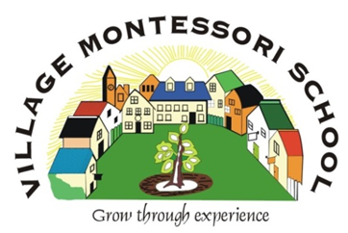
VMS HIGH SCHOOL

BROCHURE 2021

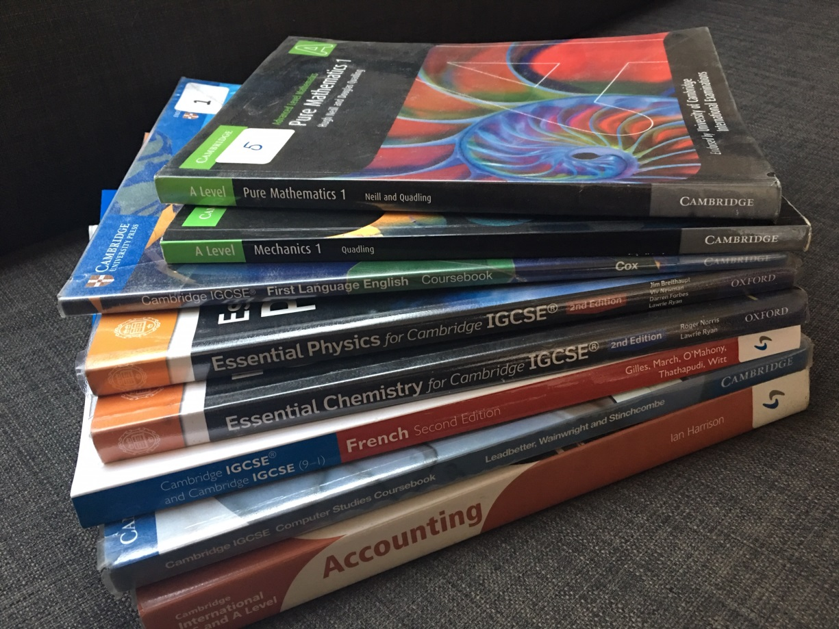

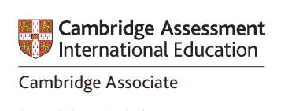

245 Glover Ave, Lyttelton AH, Centurion
info@villagemontessorischool.co.za
www.villagemontessorischool.co.za

Tel: 012 664 2944 Fax: 012 664 6681

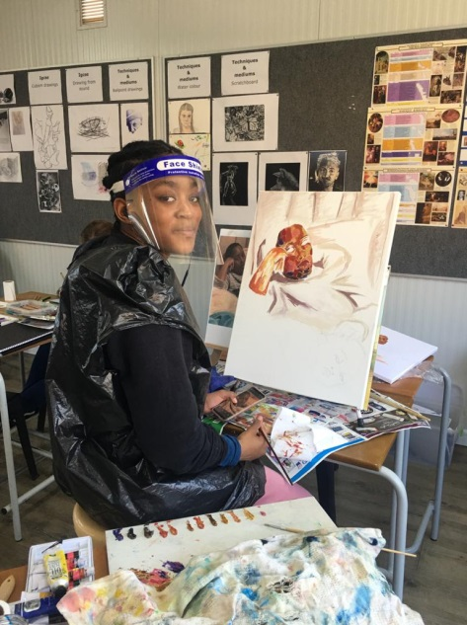
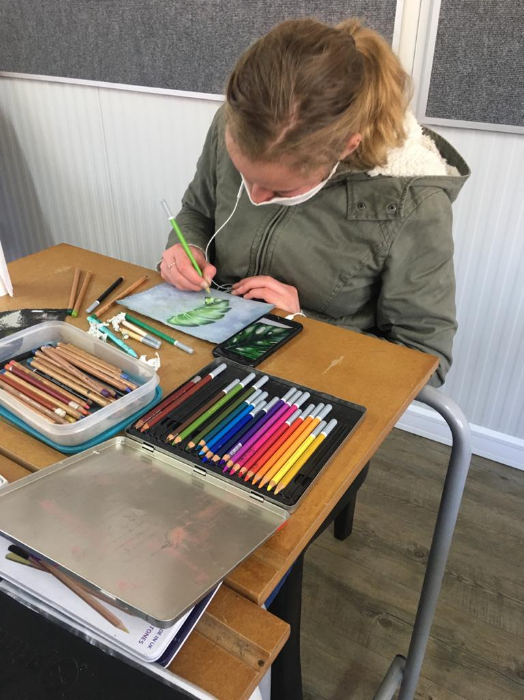
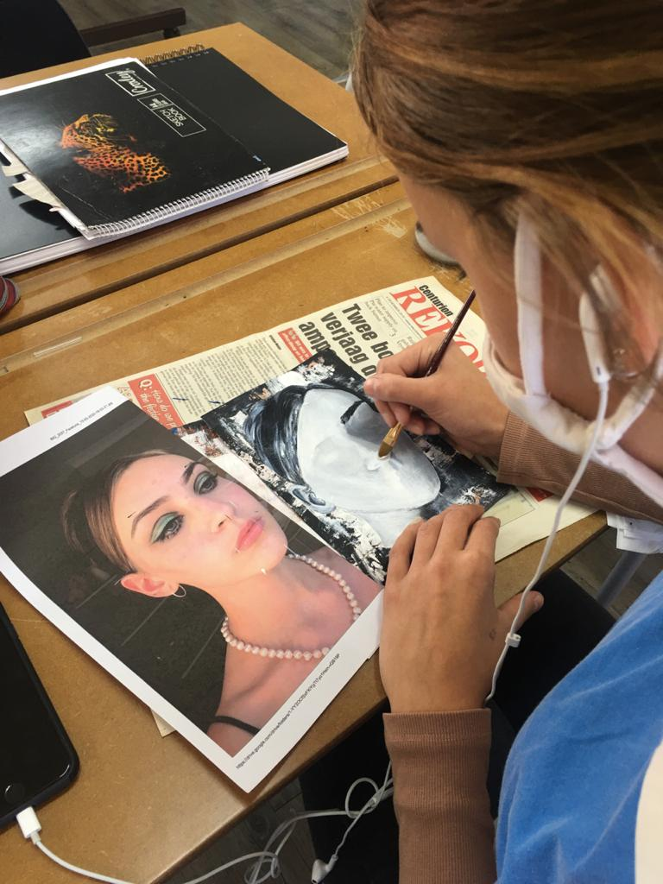

Table of Contents
Our School | 3
Why Cambridge? | 5
High School Phases | 6
Subject Choices | 7
Music, Drama and Art | 9
Community service and Cooking | 10
General information | 10
Application process | 11
School Fees for 2021 | 12
School Terms for 2021 | 13
High School Policies | 14
VMS High School of choice | 19

OUR SCHOOL

The Village Montessori Pre-, Primary- and High School was established in 1992 and is registered with the Gauteng Education Department as an Independent School.

The Examination Body for our High School is Cambridge Assessment International Education.

OUR METHOD

The school is based on the Montessori principles as compiled by Maria Montessori, a well-known Italian educator. The basis of the method is the viewpoint that each child has an innate desire to learn. The prerequisite to learning taking place is the existence of a prepared environment where the child can be directed and not taught.

Our High School students follow the Cambridge University International Curriculum from year 7 to 12. Children are allowed to study at their own pace and in a self-directed manner. The year 7 students are included in the High School as their needs differ from those in Senior Primary and the division at this phase is consistent with the Montessori philosophy where adolescents are grouped according to ages i.e. 12-15 year olds and 15-18 year olds where each grouping have different needs therefore requiring different approaches .

Montessori education at secondary level has great relevance in our modern world. Traditional high schools prepare students for further studies: they do not concentrate to the same degree on guiding young people to independence and the ability to adapt to social life. Montessori education not only prepares adolescents to take their place in working society as adults, but it also continually prepares them to be well grounded and confident.

Adolescence is that period in an individual’s life during which he or she begins the difficult transition from childhood to adulthood. Adolescents have problems, situations, needs and interests that are particular to them only. Students at this stage of their development have to cope with puberty, newfound sexuality and untapped creativity

The objective of our High school is to meet the academic and social needs and interests of the adolescent: specific consideration and allowance must be made for their beginning steps towards independence, making their own decisions, identifying themselves with others, rapid growth, and the possible lack of harmony - physically, mentally and in social relationships.

Our education goals try to include preparation for present-day and future living, adaptability to change, development of citizenship, development of self-discipline and development of personal as well as social goals.

In keeping with the above, Village Montessori High school aims to:
- encourage students to question;
- recognise individual differences;
- be facilitators of learning;
- allow students to progress at their own rate;
- allow students’ own work time;
- develop planning and problem-solving skills;
- teach communication skills;
- develop self-understanding;
- stimulate personal creativity.

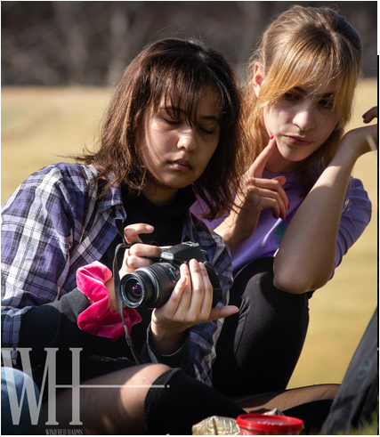

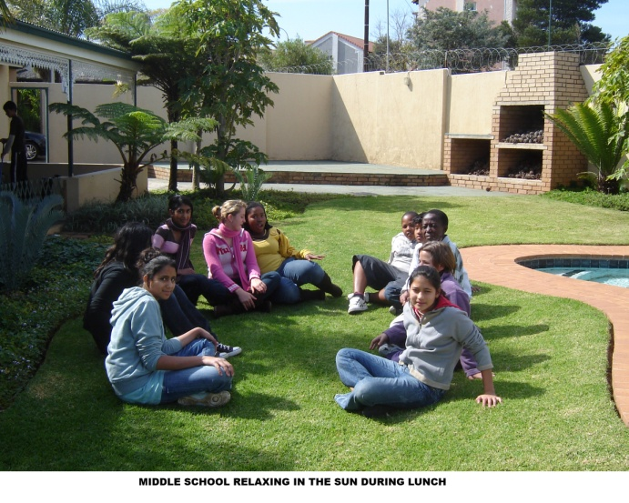

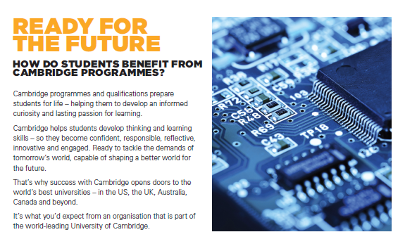
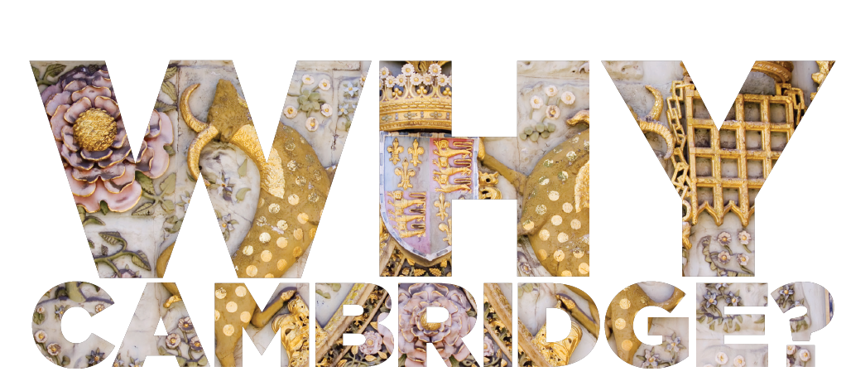

Outstanding Cambridge Learner Awards
Outstanding Cambridge Learner Awards are a group of awards issued by Cambridge Assessment International Education. They recognise exceptional learner achievement in Cambridge examinations around the world. The primary purpose of these awards is to celebrate and recognise the success of high-performing Cambridge learners.
VMS Students who received awards:
Thato Modibane November 2017: Top in the World in AS Mathematics
Taahir Mohamed November 2017: Top in South Africa in AS Marine Science
Keara Stapelberg November 2016: Top in South Africa in AS Business

HIGH SCHOOL PHASES

BRITISH COUNCIL ASSOCIATE
We are an Associate centre of the British Council. Cambridge International Assessment Education is the only exam board wholly owned by a world-leading university, the University of Cambridge. We begin the Cambridge curriculum in year 7. We align ourselves with the British time line for completing these studies.

Unlike schools that have a more traditional approach, students in our school work in a more self-directed manner and are allowed to pace themselves. We want each student to fulfil their potential and make the most of the subjects they’re best at. The Cambridge programmes are flexible and a student can accellerate within a phase. The learners are prepared for university and learns to take responsibility for their own work and achievements at a young age.

PHASES
FOUNDATION PHASE – (Grade 7 and 8)
The Foundation phase is a minimum two year program designed to give students a firm grounding in the concepts of Mathematics, Natural Sciences (Biology, Physics and Chemistry) and English. In addition to these core subjects we also offer Afrikaans, French, Social Science (History and Geography), Economic Management/Accounting, Art and Design and Computer Literacy. The students write internal examinations.
IGCSE PHASE – (Grade 9 and 10)
The International General Certificate of Secondary Education (IGCSE) is an international qualification which has been designed to equip students with the skills needed for immediate employment. The IGCSE phase provides a broad study programme by drawing subjects from five areas: Languages, Humanities, Mathematics, Creative, Technical and Vocational. Within the curriculum there is a balanced mix of practical experience and theoretical knowledge. This course is equivalent to the British GCSE or O levels and the students write external exams which are marked by University of Cambridge Assessment International Education. Students complete this phase over two years.
AS (Grade 11 and 12)
The AS-Level is the first stage of A-levels and is equivalent to year 11 and 12 of South African schooling. Due to the high academic level required students will complete the AS-level over 18 months to two years. A-level is not offered at our school.

A-Level (Post Matric)
English First Language and Mathematics are offered on the A-level. This is a post-matric qualification and can be done in the same year as the AS-level or in an additional 6 months period after the AS-level is completed.

SUBJECT CHOICES

INTERNATIONAL GENERAL CERTIFICATE OF SECONDARY EDUCATION

[IGCSE]

STUDENTS SHOULD TAKE A MINIMUM OF SEVEN SUBJECTS:

COMPULSORY SUBJECTS:

- English First Language

- Afrikaans Second Language AND/OR French Foreign Language

- Mathematics

THE REMAINDER OF SUBJECTS ARE SELECTED FROM THE FOLLOWING:

- French

- Chemistry

- Physics

- Biology

- Business Studies

- Accounting

- Economics

- Travel and Tourism

- Art and Design

- Computer Science

ADVANCED SUBSIDIARY [AS] LEVEL

STUDENTS SHOULD TAKE A MINIMUM OF 5 SUBJECTS TO OBTAIN AN EQUIVALENT TO A SENIOR CERTIFICATE WITH EXCEMPTION. ONE SUBJECT MAY BE AN IGCSE SUBJECT WITH A MINIMUM “C” SYMBOL.

- English First Language

- Afrikaans Second Language
- French Foreign Language

- Mathematics

- Physics

- Chemistry

- Biology

- Economics

- Accounting

- Business studies

- Art and design

- Travel and Tourism
- Computer Science

A- LEVEL (Pre-university level)
- English Frist Language
- Mathematics

Recognition of Qualification by Universities South Africa
For South African university entrance (exemption) a student is required to pass at least five different subjects from the correct subject groupings of which:
- 5 subjects should be on the AS level
- OR four subjects on the AS level and one on the IGCSE level (C)
- OR 2 subjects at A-Level PLUS 3 subjects at IGCSE Level (C)
- English on the AS level should be a first language, passed with a minimum of a D symbol;
- At least two are language subjects one being a first language;
- For university entrance candidates must achieve A-Level (A-E grades) AS Level (A-D grades; and IGCSE level (A–C grades).
Note: Students will need to satisfy all of these requirements over a period of not more than two (2) exam sittings (2 years).

An exemption certificate will be issued by USAF when Cambridge results are available. The fee for this certificate is not included in the school fees. Students have to apply for this certificate from USAF.

To obtain a Senior Certificate (non-university entrance) SAQA requires: A total of five subjects, including three IGCSE grades A–C plus two passes at AS Level grades A –D; OR
- A total of seven subjects, including five IGCSE subjects grades A – E plus two passes at AS Level grades A–D;
- Each of these combinations must include English as a first language.
For entry requirements to a specific university, university of technology or college in South Africa or abroad, students must confirm with the institution of their choice. To find the admission requirements online for South African universities, students should look at the ‘international’ admission requirements in each University’s admission documents.

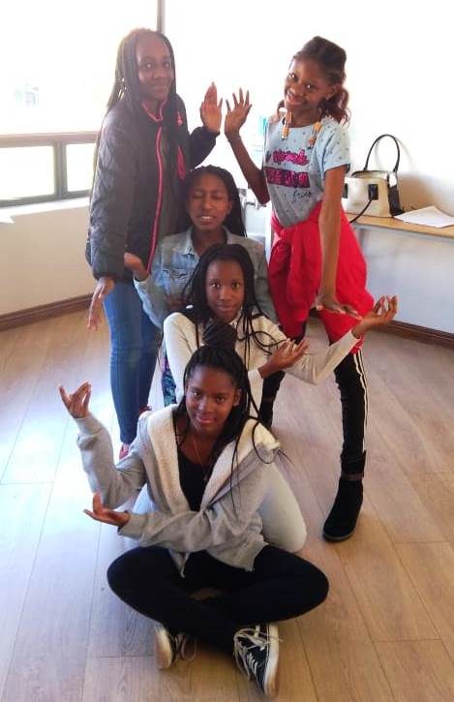
DRAMA AND ART

DRAMA AND ART are integrated into the school day. Drama and Art are compulsory for the Foundation Phase students. The approach will be a combination of formalized tuition and performance classes or opportunities.
The Drama and Art team up to putt a production on towards the end of the year.
A. DRAMA Lessons are geared towards building self-confidence and stage presence and will include the following aspects: acting skills, characterization, mime, make-up, dance, stage confidence and voice projection.

B. ART & DESIGN:
All Foundation phase school students take Art as a subject. At the IGCSE and AS levels, students can choose Art and Design as a subject. It is recognised for exemption purposes.
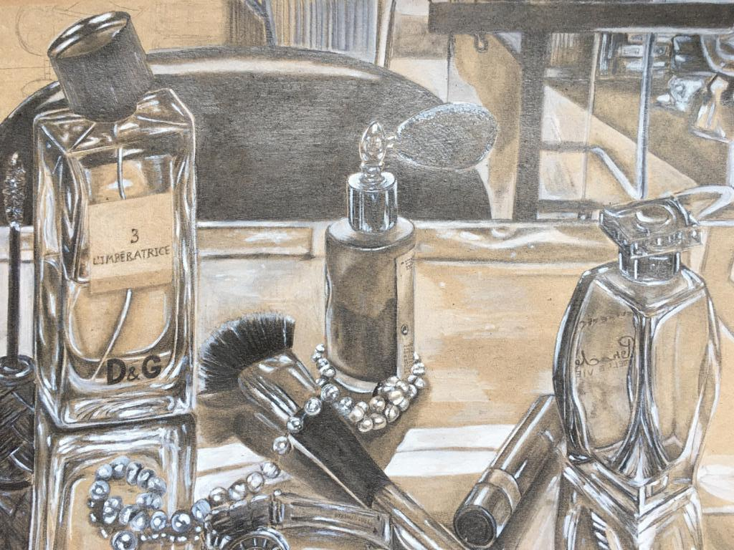

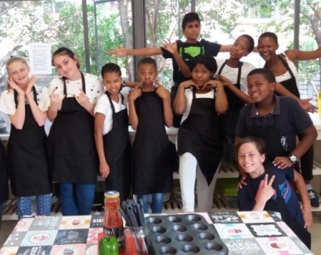
COMMUNITY SERVICE AND COOKING
The Foundation 1 students receive cooking lessons from Carla [SP] on Tuesday afternoons.
The High School children assist with some of the VMS events such as open days, Primary School Drama productions; sport days etc. and share their expertise when required.

GENERAL INFORMATION
ALL PHASES | Monday to Thursday | 7:45 - 15:00
 | Friday | 7:45 - 13:00

- Tutorials start strictly at 7h45. No latecomers will be allowed to enter the classrooms and disrupt tutorials.
- Aftercare is available until 17:30. High School students pay R40 p.d. starting from 15:15 weekdays and 13:15 on Fridays up to 17:00.
- A cooked lunch can be ordered at R25 per meal.
- Staff/pupil ratios: (HS: Foundation Phases to AS) = 1:15 this is a guideline only
- We have a three term year.
- No school uniform is prescribed. Students have to be dressed in an acceptable fashion.
- We encourage healthy eating and therefore have a strict food policy.
- A five percent discount is granted on sibling’s fees and ten percent discount on fees paid in full before 31 January.
- Three month’s written notice is required in the event of a student leaving the school in order to receive a full refund of the deposit.
- Parents need to reinforce the methods used at school at home as well.

APPLICATION PROCESS

We are selective when it comes to admitting students because the groups are small and we need to ensure that the appropriate atmosphere of learning and respect is maintained at all times. Only students with impeccable personal records will be considered. Our school is committed to building a close community and it is important to build a relationship with the family. Our admissions process attempts to gather a picture of each applicant that will be as complete as possible. It includes one or more classroom visits, interviews, assessment of the applicant, and a review of the student’s academic record.

Once the application form and report card/Cambridge Certificate are received, an invitation for an assessment will be sent to the parents. An application fee of R1 500-00 is payable before the assessment. After a successful assessment, parents will be informed and invited to an interview at the school.

High School students are expected to spend a day at the school to enable them to experience Montessori/Cambridge education for themselves before making a final decision. We also need time to ascertain whether or not the prospective student will prosper in a Montessori setting. If your child is accepted, the Good Faith Deposit is payable within the time stipulated to secure their place in the school.

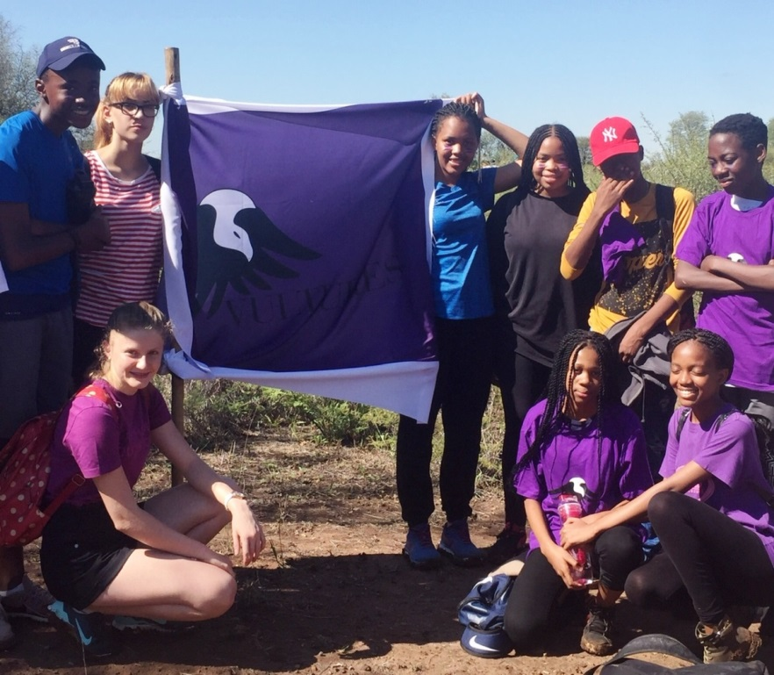

HIGH SCHOOL FEES FOR 2021

FOUNDATION PHASE (GR 7 and GR 8)
Application fee: R1 500.00 Non Refundable
Good Faith Deposit: R25 000.00
Monthly fee: R 8 350.00 (X 11)
This fee includes: School fees up to 15:00, Occupations and
Academic Materials: Work programmes and text books.
Aftercare fee per day: R40 from 15:15 up to 17:30 per child per day
Meals per day: R25 per meal per child
Sibling discount: 5% on monthly school fees
School fees paid upfront by 31 January for the year: 10% discount

CAMBRIDGE IGCSE AND AS PHASES (GR 9 - GR12)
Application fee: R1 500.00 (Non -Refundable)
Good Faith Deposit: R28 000.00
Monthly fee: R 9 620.00 (x 11)
This fee includes: Tutoring fees up to 15:00, all academic materials i.e. work programmes, textbooks and External Exam Fees
Aftercare fee per day: R40 up to 17:00 per child
Meals per day: R 25 per meal per child
Sibling discount: 5% on monthly school fees
School fees paid upfront for the year by 31 January: 10% discount

Annual payment upfront carries a 10% discount if paid before 31/01/2021
Fees are payable on the 1st of the month in advance for 11 months of the year (January to November).

BANKING DETAILS
Nedbank Centurion
Branch no: 162-145
Account no: 1621 138 658
Cheque (Current) account
Name: Village Montessori School
Please use child’s name and surname as a reference.

Proof of payment can be emailed to: daleen@villagemontessorischool.co.za

SCHOOL TERMS 2021

TERM 1

School Opens: Wednesday 13 January
Mid-term School Closes: Thursday 25 February
Mid-term School Opens: Tuesday 02 March
School Closes: Wednesday 14 April 11:00

TERM 2

School Opens: Wednesday 05 May
Mid-term School Closes: Friday 11 June
Mid-term School Opens: Monday 21 June
School Closes: Friday 06 Aug 11:00

TERM 3

School Opens: Tuesday 07 September
Public Holiday: Friday 24 September Heritage Day
Mid-term School Closes: Thursday 21 October
Mid-term School Opens Tuesday 26 October
School Closes: Friday 03 December 11:00

TERM PLANNER

A comprehensive term planner will be sent out at the beginning of every term in the Weekly Notices.

HIGH SCHOOL POLICIES
Maria Montessori developed the concept of “normalisation” to describe the process by which each child acquires certain personality characteristics that lead to success in the classroom and throughout life. A “normalised” child will love learning, be kind to others, develop concentration and good work habits, and become independent.
VMS is built on the concept of a community. A community shares common values. Its members seek to give as much as they are able for the good of the whole, and take only what they really need. The community seeks to raise the level of the lowest members while keeping the entire community progressing forward toward a shared vision. At VMS High School, we value:
- Respect for ourselves, others and the environment;
- Honesty;
- Courtesy and exceptional manners;
- Empathy for others and respect for differences among people and cultures;
- Responsibility for personal decisions and actions;
- Cooperative work with others, which includes listening, sharing options, negotiating, compromising, helping to reach consensus, and taking a stand;
- Seeking one’s share of the work load;
- Creating balance between the needs of individual students and families and the needs of the school population as a whole; and
- Pride in our school.

1. CELL PHONES AND TABLETS:
- High School students are allowed to bring their cell phones to school to facilitate contact with parents and for academic purposes only. It should be out of sight and switched off during academic time.
- Students are allowed to phone parents from the High School Office or their own cell phones during breaks or after school only in the High School Building and with permission from a staff member.
- They are allowed to listen to music with ear phones with permission from a subject teacher:
- During Art Classes
- During Academic periods to help them concentrate when they are busy with class work [only senior students].
- No cell phones are allowed on the premises of the primary school or outside the high school buildings. No earphones are allowed outside the High School Building.
- Cell phones may be used for research under supervision of subject teachers.
- Tablets and laptops are only allowed when students are busy with a research project and are requested by subject teachers to bring it to school. It will always be at the student’s own risk.
- Cell phones will be if any of these privileges are abused.

2. ABSENTEEISM
Students are expected to be at school during the term unless one of the following valid reasons applies:

They are genuinely ill;
- the family experience a trauma such as bereavement etc.;
- the student belongs to an external sports club and is required to go on tour;
- absence is motivated and permission is granted;
Please note:
- Holidays should be arranged during official school holidays.
- Absenteeism which occurs on a day preceding or following a weekend, long-weekend, mid-term break or school holiday, or on a day a test or examination is written, requires the submission of a valid sick note on the day of the student’s return to school.
- The school ceases to take responsibility for a student who is absent for more than 15 school days.

3. LEAVING EARLY/ DOCTOR’S APPOINTMENTS
Lucky is under strict orders not to allow students out during school time without written permission from the class teacher for security reasons. Please inform the class teacher or send a note to school should your child have a doctor’s appointment and we will gladly provide an early leaver’s slip. In the case of extra murals, kindly ensure that you child’s external extra murals begin after 15h00 on week days.

4. AFTERCARE
Aftercare begins at 15h15 and closes at 17h00. High School students pay R35 per day. High School students will join the rest of the school in aftercare from 16h00 to 17h00. A student will be accommodated on occasion at the gate from 17h00 to 17h30 but must be collected by 17h30 at the very latest. High School students who are collected after 17h30 will not be accommodated in our aftercare. Parents have at times contacted Lucky directly when they are running late. Please do not contact Lucky as he starts his day very early and will not be allowed to supervise your child after 17h30. A fee of R150 per 5 minutes will be charged from 17h30 to be paid when collecting your child.

5. DRESS CODE
- Girls are allowed to wear shorts of an appropriate length.
- No underwear should be visible. This applies to boys and girls.
- Straps of tank tops are allowed to show with spaghetti strap tops provided they are more or less the same colour as the tops they are wearing.
- No cleavage is allowed.
- Leggings must be worn with a long top that covers the buttocks.
- Please keep in mind that this is an Academic Environment.

6. HOME/SCHOOL COMMUNICATION
Changes in a child’s home life may affect his/her behaviour and performance at school. Please notify the office and your child’s teacher if any significant changes occur, such as:
- Extended vacations or business trips by a close family member;
- Child staying somewhere other than at home (a relative/friend’s house) for more than a day or two;
- Loss of family member, including pets;
- Moving house;
- Change in a family environment (separation, divorce, new partner, new baby);
- Serious illness or hospitalisation of a family member.
Please note that this information will be strictly confidential.

7. DISCIPLINE

BEHAVIOURAL EXPECTATIONS
In the School context, teachers, parents and pupils have responsibilities. To sustain a healthy learning environment, it is important that these parties to the education relationship acknowledge their respective responsibilities.
The School prides itself on having good relations with the parents of pupils. While parents must expect the School and its teachers to provide the best education possible with the resources available to the School, parents must also accept responsibility to help the School achieve this goal.
The School recognizes that every pupil does have the right to education. Pupils themselves must however also recognize that they have responsibilities to their parents, the School, Teachers, their fellow pupils and themselves.
Pupils must therefore:
- Comply with instructions and the general rules of the School.
- Behave responsibly and not endanger the safety and welfare of others;
- Respect and care for the property of the School and others;
- Maintain sound relations with others at School, be courteous and respect the dignity and self-worth of others;
- Be punctual and observe the timekeeping practices of the School;
- Demonstrate a positive attitude towards the opportunity to learn, and be diligent in their efforts to learn;
- Behave honestly and conduct themselves with integrity;
- Accept the authority of Teachers.
- Accept legitimate punishment and disciplinary action taken against them.

MANAGING/ADDRESSING POOR BEHAVIOUR: PROCESS
If a child exhibits unacceptable behaviour, the following disciplinary action will be taken, according to the severity of the misbehaviour.
- The High School’s Disciplinary Code for pupils, is intended as a penalty guideline for Teachers. It may be deviated from to accommodate specific circumstances.
- It indicates the maximum disciplinary action generally considered appropriate for various types of infringements and misconduct by pupils. The circumstances of a particular case under consideration may justify less severe action than that indicated in the Code.
- The infringements listed in the Code are not intended to be an exhaustive listing but rather an indication of the type of deviation from expected standards of conduct, and the levels of severity of infringements.
- Please note that the Code does make provision for "progressive" or accumulative penalty i.e. the imposition of a harsher sanction for repeated misconduct, in the case of less serious infringements.

DISCIPLINARY MEASURES
- Various forms of informal and formal disciplinary measures may be initiated by VMS High School. The severity of the action taken by the school will depend on the circumstances, the seriousness of the infringement and any mitigating or aggravating factors that are of relevance.

- The disciplinary measure or penalty applied in response to the pupil's misconduct will therefore generally require the Teacher or Head to exercise discretion in deciding on the appropriate and fair action to be taken.

- Discipline must be feasible and effective, be applied progressively. Repeated commission of a similar or related offence will result in progressively more severe action being taken, particularly where a clear pattern or trend is indicated by the pupil's continued misconduct. A serious first incident may however justify a severe penalty

- Disciplinary action that may be applied by the School, in order of severity, includes:

INFORMAL ACTION
- counselling by the Teacher;
- detention or time punishment; extra duties , confiscation of items used inappropriately;
- referral to Head:
- The Head must investigate the complaint and alleged infringement to gather information and to decide on the necessity for corrective measures. This assessment generally takes the form of an informal investigation, which may, if appropriate, include an opportunity for the pupil to "state his case" in response to the complaint.
- If, after investigation, the infringement is confirmed but is considered to be of a nature which does not indicate that severe action may be appropriate, the Head may issue a punishment appropriate to the nature of the infringement, counsel the pupil(s) and issue an appropriate warning to the pupil(s) concerned. It should be pointed out that the investigation to be conducted is an informal one, and that suspension or expulsion is not considered as appropriate action at this point.

FORMAL ACTION
A pupil may, at the discretion of the Head, be called before the Management for a formal disciplinary hearing.
Warnings issued by the School will be noted on the pupil's record. Copies of warnings issued should also be provided to the parents wherever possible.
VMS reserves the right under law to exclude students from school for offenses such as, but not limited to, poor school citizenship, disrespect for school personnel or property, poor or unexcused school attendance, unacceptable health or safety standards, poor ethical or moral values, sexual harassment and drug or alcohol involvement.

EXAMPLES OF BEHAVIORS REQUIRING DISCIPLINARY RESPONSES
It is impossible for the code to list every possible rule infringement and this guideline and the attached Code therefore set out the broad principles for the implementation of fair discipline at VMS High School. The Staff are entitled to apply action that they believe is appropriate in the circumstances, with regard to the guidelines provided by this procedure and code.
At the discretion of the staff, disciplinary action may be taken for infractions of school rules and regulations.
- Poor school citizenship
- Disrespect for school personnel;
- Bad language;
- Intimidation of other students/bullying
- Dishonesty;
- Disrespect for school property; littering
- Tardiness
- Unacceptable manners or dress
- Unacceptable health or safety standards
- Leaving class rooms without permission
- Disrupting classes
- Inappropriate use of cell phones and ear phones
- Unfinished work or homework not completed

The director/directress will:
- Provide a structured environment in which a child feels secure and confident to work.
- Set behavioural expectations through classroom instruction, role modelling, and classroom meetings;
- Discuss classroom rules and Montessori Standards of Behaviour;
- Redirect a child and use conflict resolution techniques;
- Work one-on-one with children who need additional guidance;
- Keep a record of conflict situations or negative behaviours;
- Keep parents informed about discipline problems;
- Refer a child to play therapists, educational psychologists, occupational therapists when necessary, to determine ways to help him/her succeed in and out of the classroom.

PARENT/GUARDIAN’S ROLE IN SUPPORTING POSITIVE BEHAVIOUR
Modelling
A parent is the most important teacher in a child’s life. Children observe and imitate the behavioural responses that are used by the significant adults in their environment. Parents who are respectful and kind to others, especially their own children, are likely to see that same behaviour develop in their children. Demonstrating a variety of healthy responses to frustration and set-backs, as well as modelling effective problem-solving techniques and non-judgmental communication are especially valuable to young children who are still learning to establish self-control.
Discussion
While children absorb a great deal by observation, discussing ways to show respect, build trust, show empathy, manage anger, and practise forgiveness can help a child build successful relationships.
Reinforcement
Montessori philosophy does not advocate external rewards for desired behaviour, as this tends to reduce intrinsic motivation. However, acknowledging and praising positive behaviour is always important and will shape a child’s behaviour far better than criticism. Setting clear boundaries for socially acceptable behaviour is essential.

VMS: SCHOOL OF CHOICE

VMS is a school of CHOICE. Students who are unable to progress or become responsible, independent, and productive members of the Montessori Community have demonstrated that they do not represent a best fit for the principles and values of VMS. Traditionally, public schools offer a more structured group approach to instruction and classroom set-up and this approach may be more suitable for some children and their families.

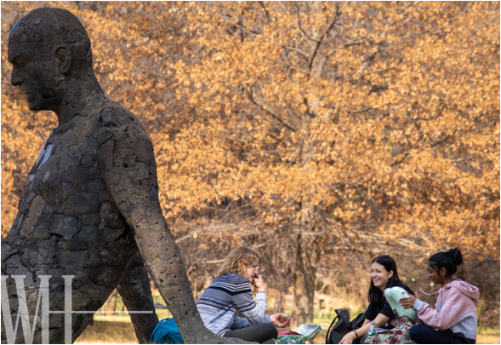
Parent understanding and support of the expectations established by VMS is vital to each child’s behaviour and successful performance. As mentioned in much of our literature, this is a COMMUNITY EFFORT. While children should not be denied access to educational opportunities based on their parents’ unwillingness to follow strategies outlined for success, these same children cannot be permitted to interrupt the learning environment or compromise the safe ty of others.

