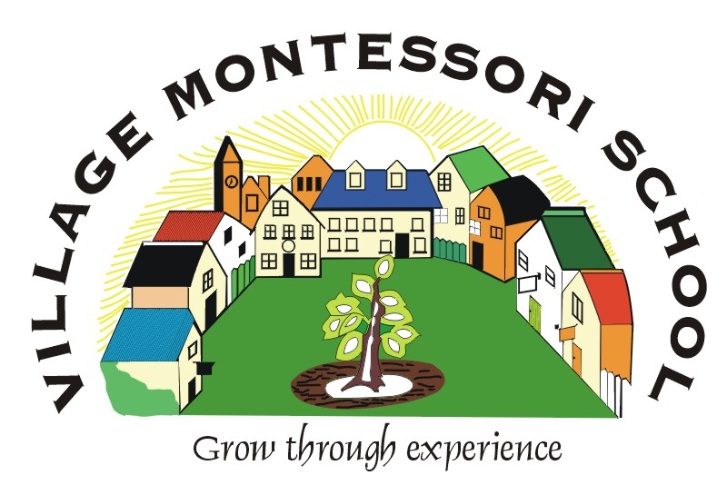

PRE-SCHOOL,
PRIMARY SCHOOL
2019

245 Glover Ave, Lyttelton AH, Centurion

Tel: 012 664 2944
Fax: 012 664 6681
Email: enrollments@villagemontessorischool.co.za
info@villagemontessorischool.co.za
Website: www.villagemontessorischool.co.za

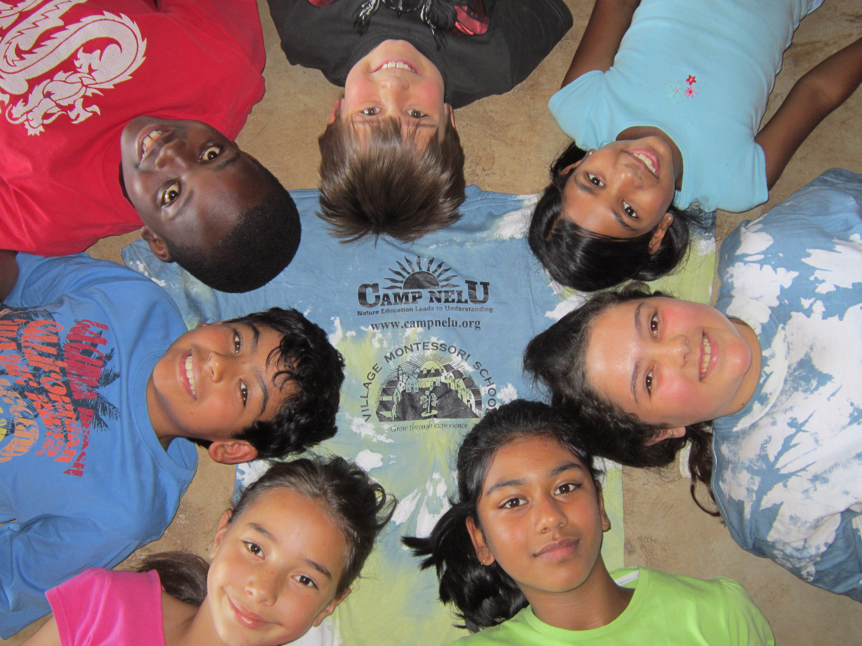
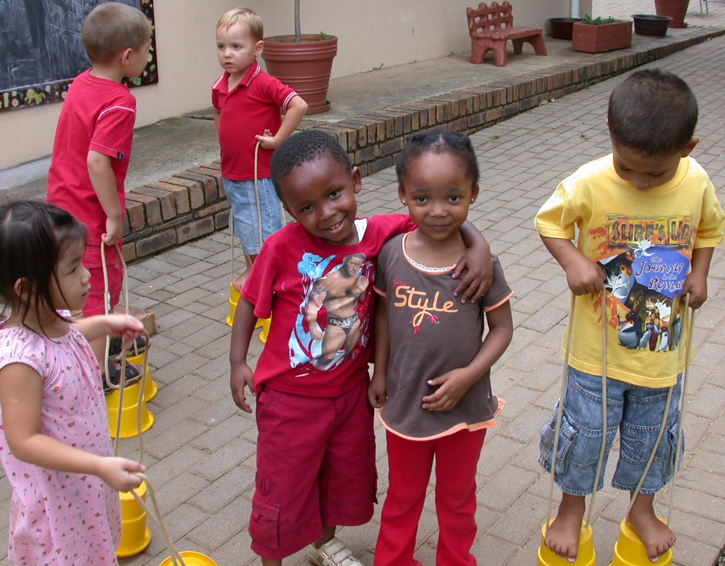
Our School

The Village Montessori School was established in 1992 and is registered with the Gauteng Education Department as an Independent School.

The examination body for our High School is the Cambridge International Examination Board. Please see the High School Brochure for more details.

Our Method

The school is based on the Montessori principles as compiled by Maria Montessori, a well known Italian educator. The basis of the method is the viewpoint that each child has an innate desire to learn. The prerequisite to learning taking place is the existence of a prepared environment where the child can be directed and not taught.

Mixed age classrooms
Montessori classes are separated into three year cycles so that the child is placed with others in a classroom of peers that are in the same developmental stage as they are.
The children benefit from this arrangement in many ways:
- Younger children learn from older children through observation.
- Older children can present work to younger children – this benefits the younger child and the older child’s sense of self esteem and competence is enhanced.
- The daily interaction between the older and younger children gives them the advantage of observing conflict resolution and other social skills at their level of understanding and stage of development. Older children learn tolerance and patience with the younger children and begin to see themselves as role models. The younger children in turn look up to older children and turn to them for guidance and help.
- Because we encourage children to work at their own pace, they are not pressured to achieve what others in their age group are achieving. This not only benefits the child who needs more time to consolidate information and skills, but gives the child who is ready to move onto more advanced work the opportunity to do so.
- A sense of community is enhanced, where everyone plays a role in the smooth running of the class.
- The behaviours that frustrate us as parents (like children refusing to put things away), often don’t present themselves in the classroom where the peer group quickly step in and correct the issue. This is done in such a way that the child doesn’t feel like she/he is being reprimanded, and easily complies.

Ages 3 – 6:
We offer a wide range of educational opportunities for children during the important early formative years. Beginning with practical and social skills, children learn to keep track of their belongings, to put things away, and to share materials. Academics are introduced through concrete, manipulative materials which utilise all five senses and lay the groundwork for abstract thinking.

Exercises of Daily Living
These activities, which Dr Montessori called "Practical Life", prepare children to care for themselves and the environment and give each child a sense of mastery and self-confidence. Performing such tasks as sweeping, polishing, washing, and preparing food, children develop coordination, concentration, and good work habits such as completing a task.

Sensorial Exercises
Montessori materials are designed to heighten the child's senses of sight, touch, sound, taste and smell. By focusing on the senses, children are given a key to understanding and classifying the environment. Distinguishing, categorising, and comparing the concrete lays the foundation for understanding the abstract.

Mathematics
Children's understanding of the basic mathematic operations of addition, subtraction, multiplication, and division emerges from using manipulative materials such as rods, beads, sandpaper numerals, cards and counters which allow the child to visualise the abstraction of numbers. Using self-correcting materials, children learn not only number recognition and place value, but also to solve problems and to develop a visual image of mathematical concepts.

Reading and Writing
The pre-school child is immersed in developing language, and effortlessly links sound, symbols and shapes. Using simple alphabet cut outs and sandpaper letters, children learn the sounds of letters and soon are linking letters to make words, then words to make sentences.

Children first develop small muscle coordination necessary to master writing in their activities of daily living and in using the sensorial materials. After tracing geometric figures with a pencil, cutting shapes with scissors, and tracing letters with their fingers, they soon progress to writing letters.

Cultural Subjects
History, geography, science, art, and music are referred to as cultural subjects. Children learn about people, their countries, and the world through food, music, pictures, flags, maps, artifacts, the celebration of holidays, and scientific experiments and observations.

To aid the child's understanding of biology and to enhance the student's love of nature and experience with living things, the school often invites groups to bring animals to the school, for example fish, reptiles, amphibians, birds, and mammals. Small gardens and plants are cared for by the children.

Primary School, ages 6 – 12:
The Pre-School experience continues in the primary programme, where the Montessori materials are a means to an end. These scientifically designed materials are intended to stimulate the imagination, to aid abstraction and to present a universal view of the human work and purpose.
The child is led to ask philosophical questions about the origins of the universe, the nature of life, different cultures, and the fundamental needs of humankind. Interdisciplinary studies combine geology, biology, chemistry, physics and anthropology in the study of natural history and world ecology.

World history is integrated with science and language and is presented through the medium of "Great Stories" or lessons which span the history of the universe, supported by impressionistic charts and multiple time lines for each major concept presented.

The mathematics curriculum is presented with concrete materials which reveal arithmetic, geometric, and algebraic correlations. Formulae and rules are a point of arrival and discovery, not a point of departure.

There is an emphasis on creative and expository writing, interpretive reading of literature and poetry. Research using a variety of sources is basic, as is the study of grammar, sentence analysis, spelling and oral expression, including dramatic and operatic productions. A foreign language is developed alongside the native language.

Making use of community resources through the experience of outings is a means of allowing students to take the initiative to explore beyond the classroom walls and to follow their own interests to a satisfying conclusion.

Art and music hold an equal place in the Montessori Curriculum, both in theory and in practice. These areas are also included in the integrated curriculum, demonstrating the richness of the human mind and spirit.

High School:
Our High School students follow the Cambridge University International Curriculum. Students are allowed to study at their own pace and in a self directed manner. Tutors are available in class and online.
For more information on our High School please see the High School brochure.

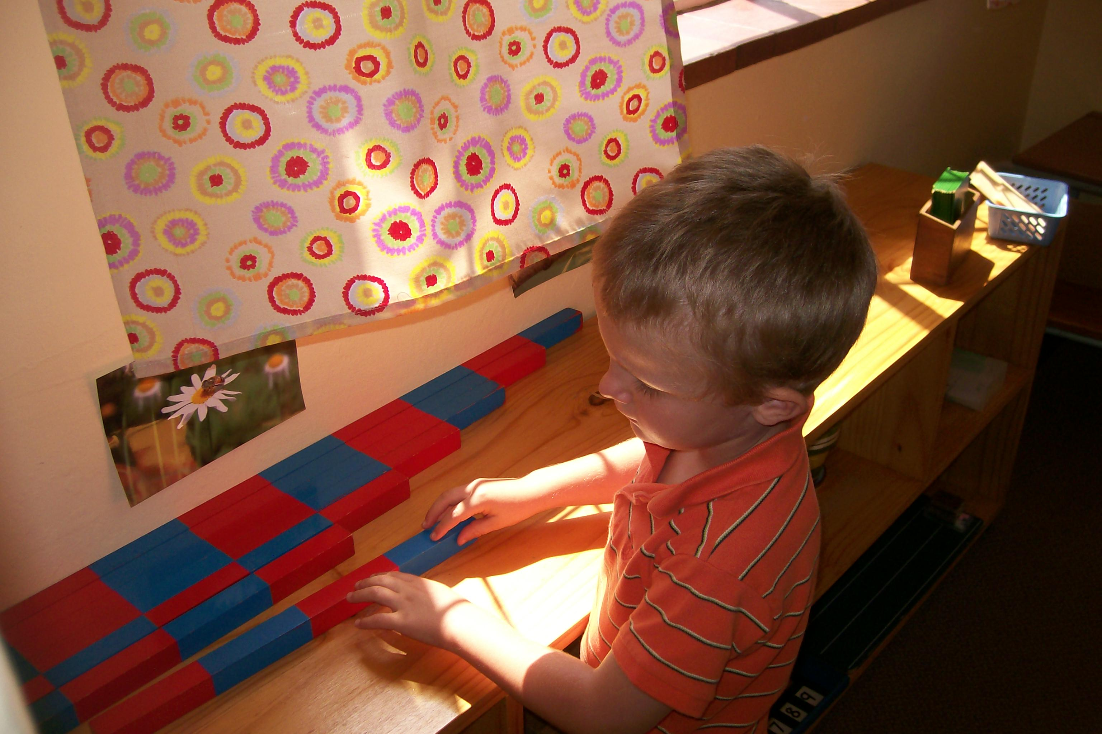
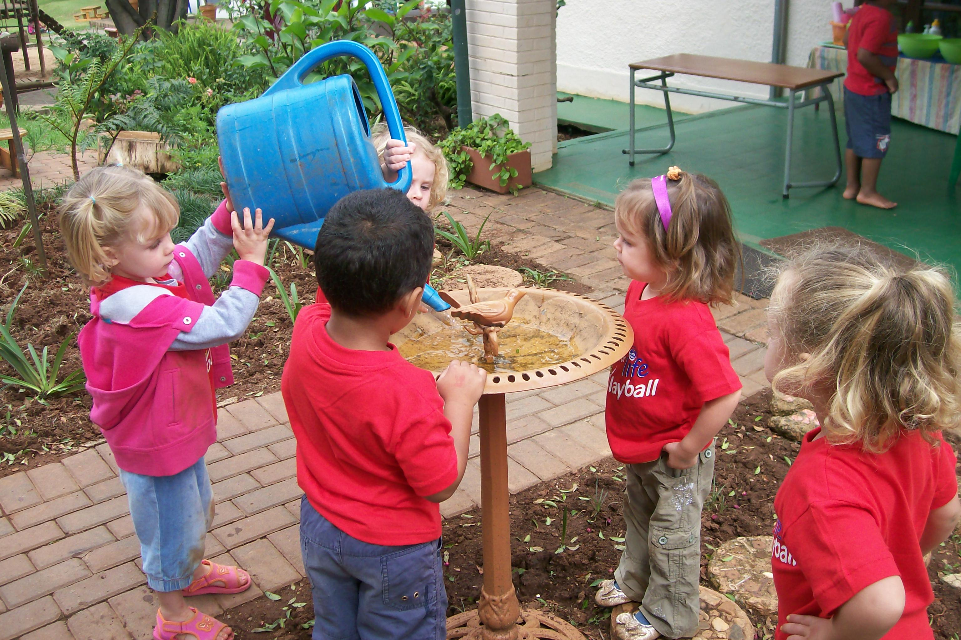
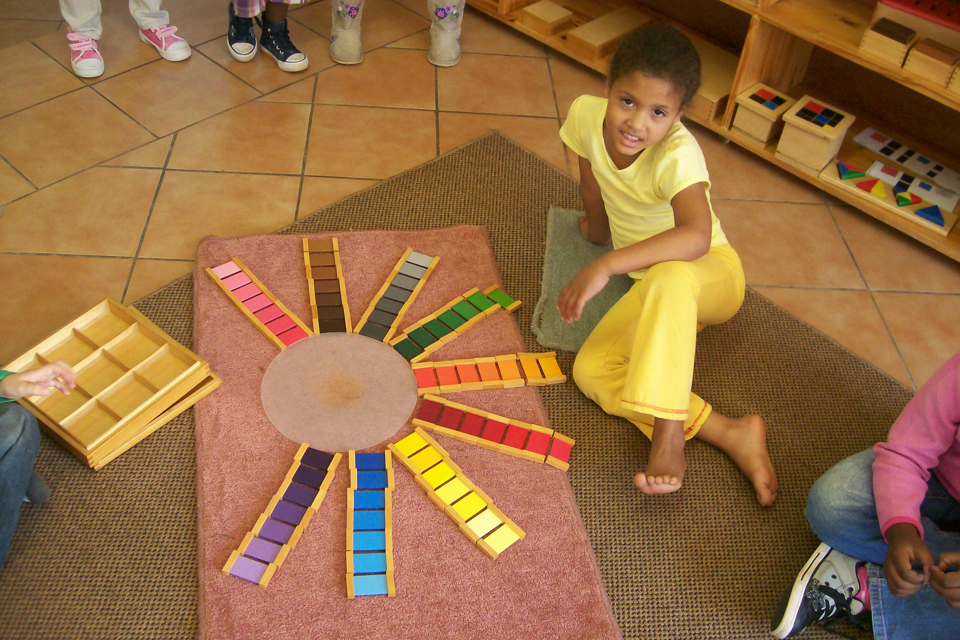

We offer

- Holistic education that aims to meet the needs of the pupils academically, physically and emotionally.
- The prepared environment contains Montessori didactic equipment which allows concrete experiences of concepts.
- We encourage understanding through a questioning mind.
- Classes are small and consist of a mixed age group, fostering a community spirit and ensuring that the needs of every child are met.
- Outings enrich children’s experiences and the Primary and High School children go on an annual camp.
- Chess is offered as a subject to all Grade 1 to 6 children.
- All Pre-School, Junior and Senior Primary children attend music lessons once a week.

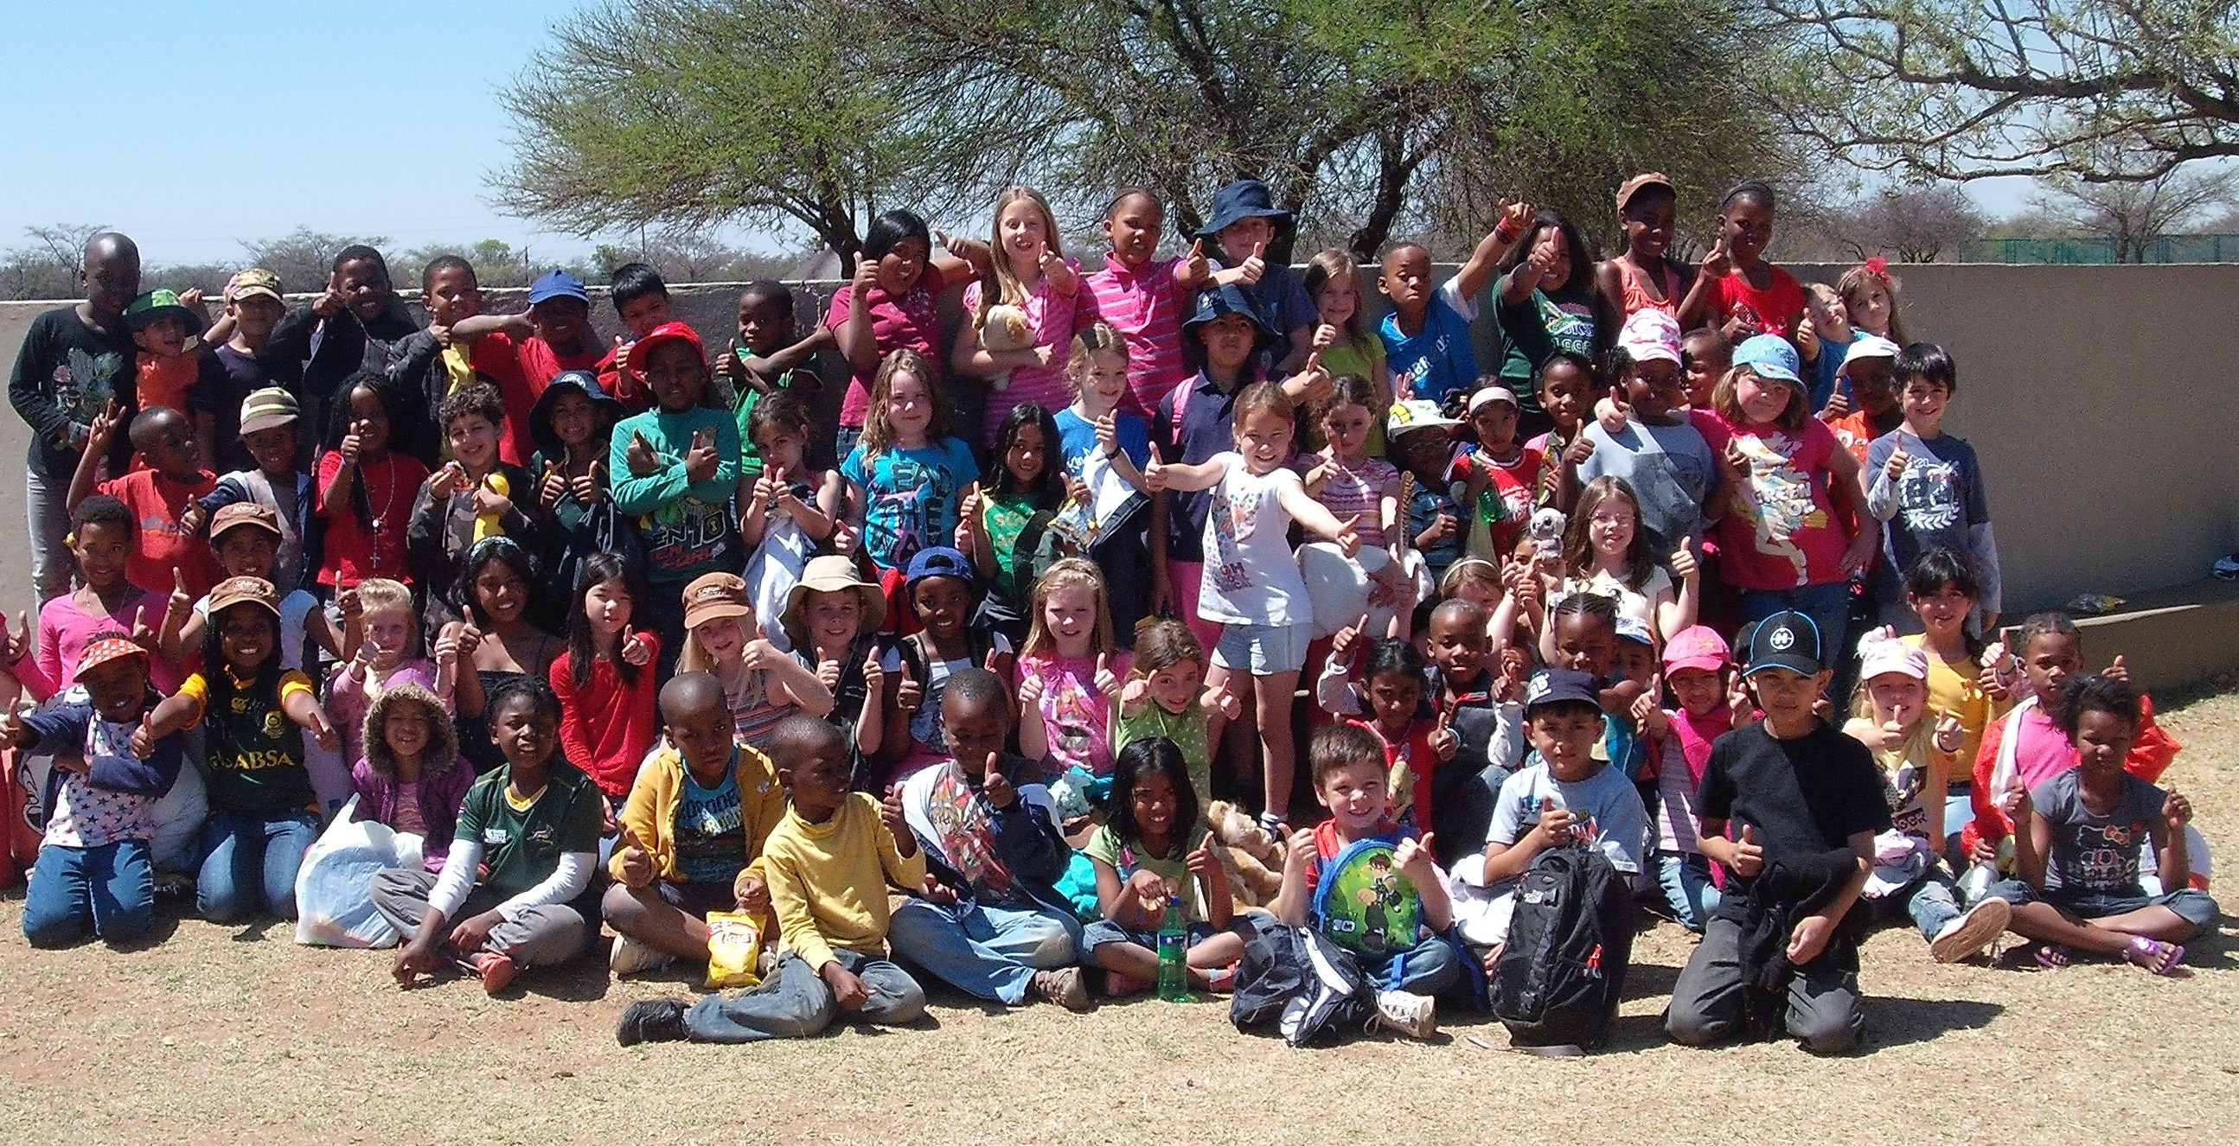
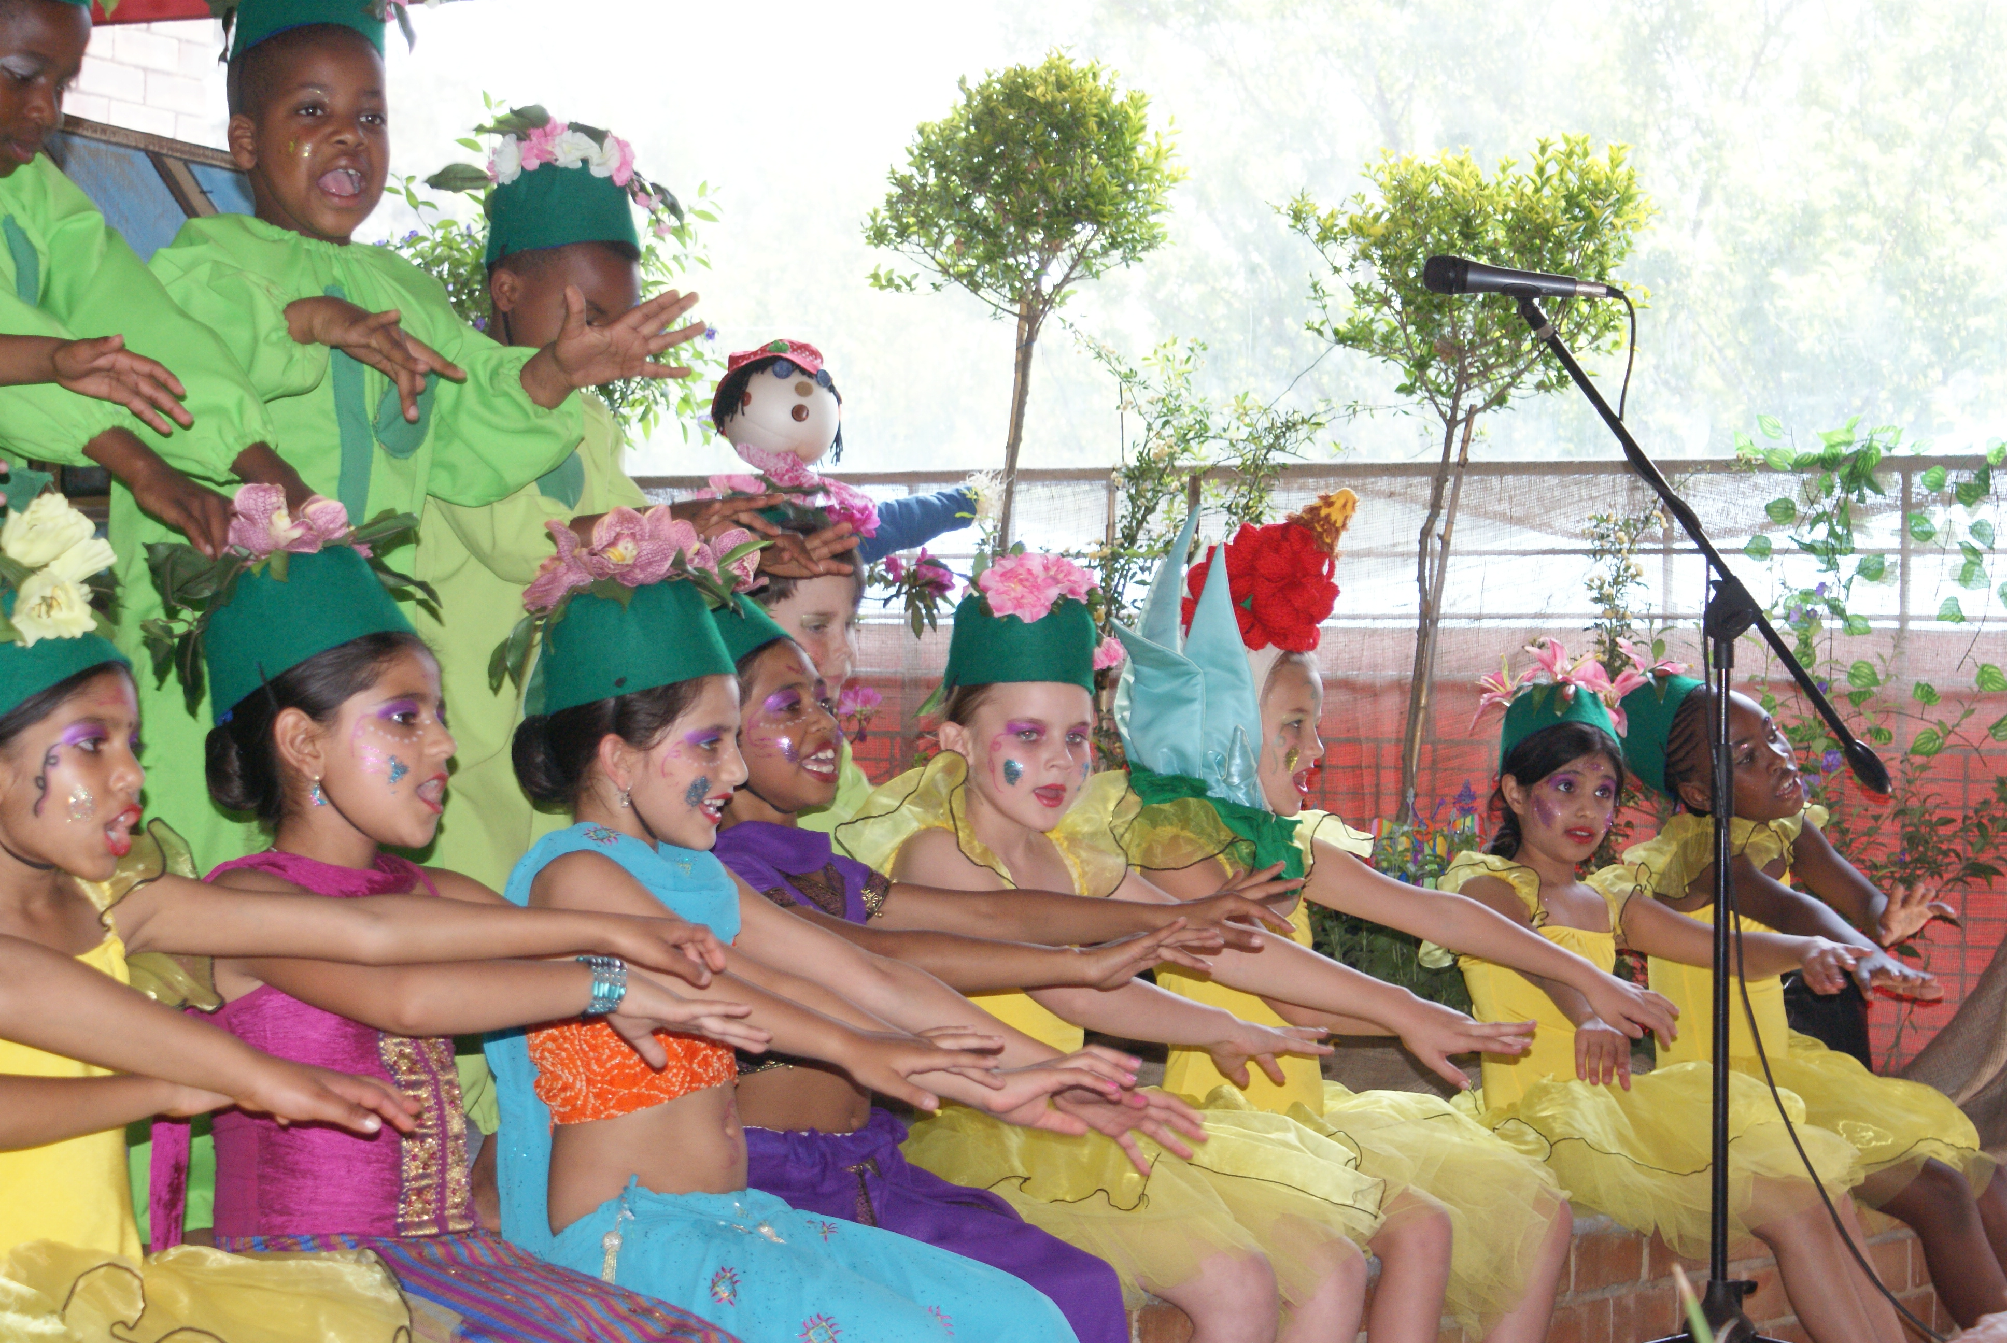

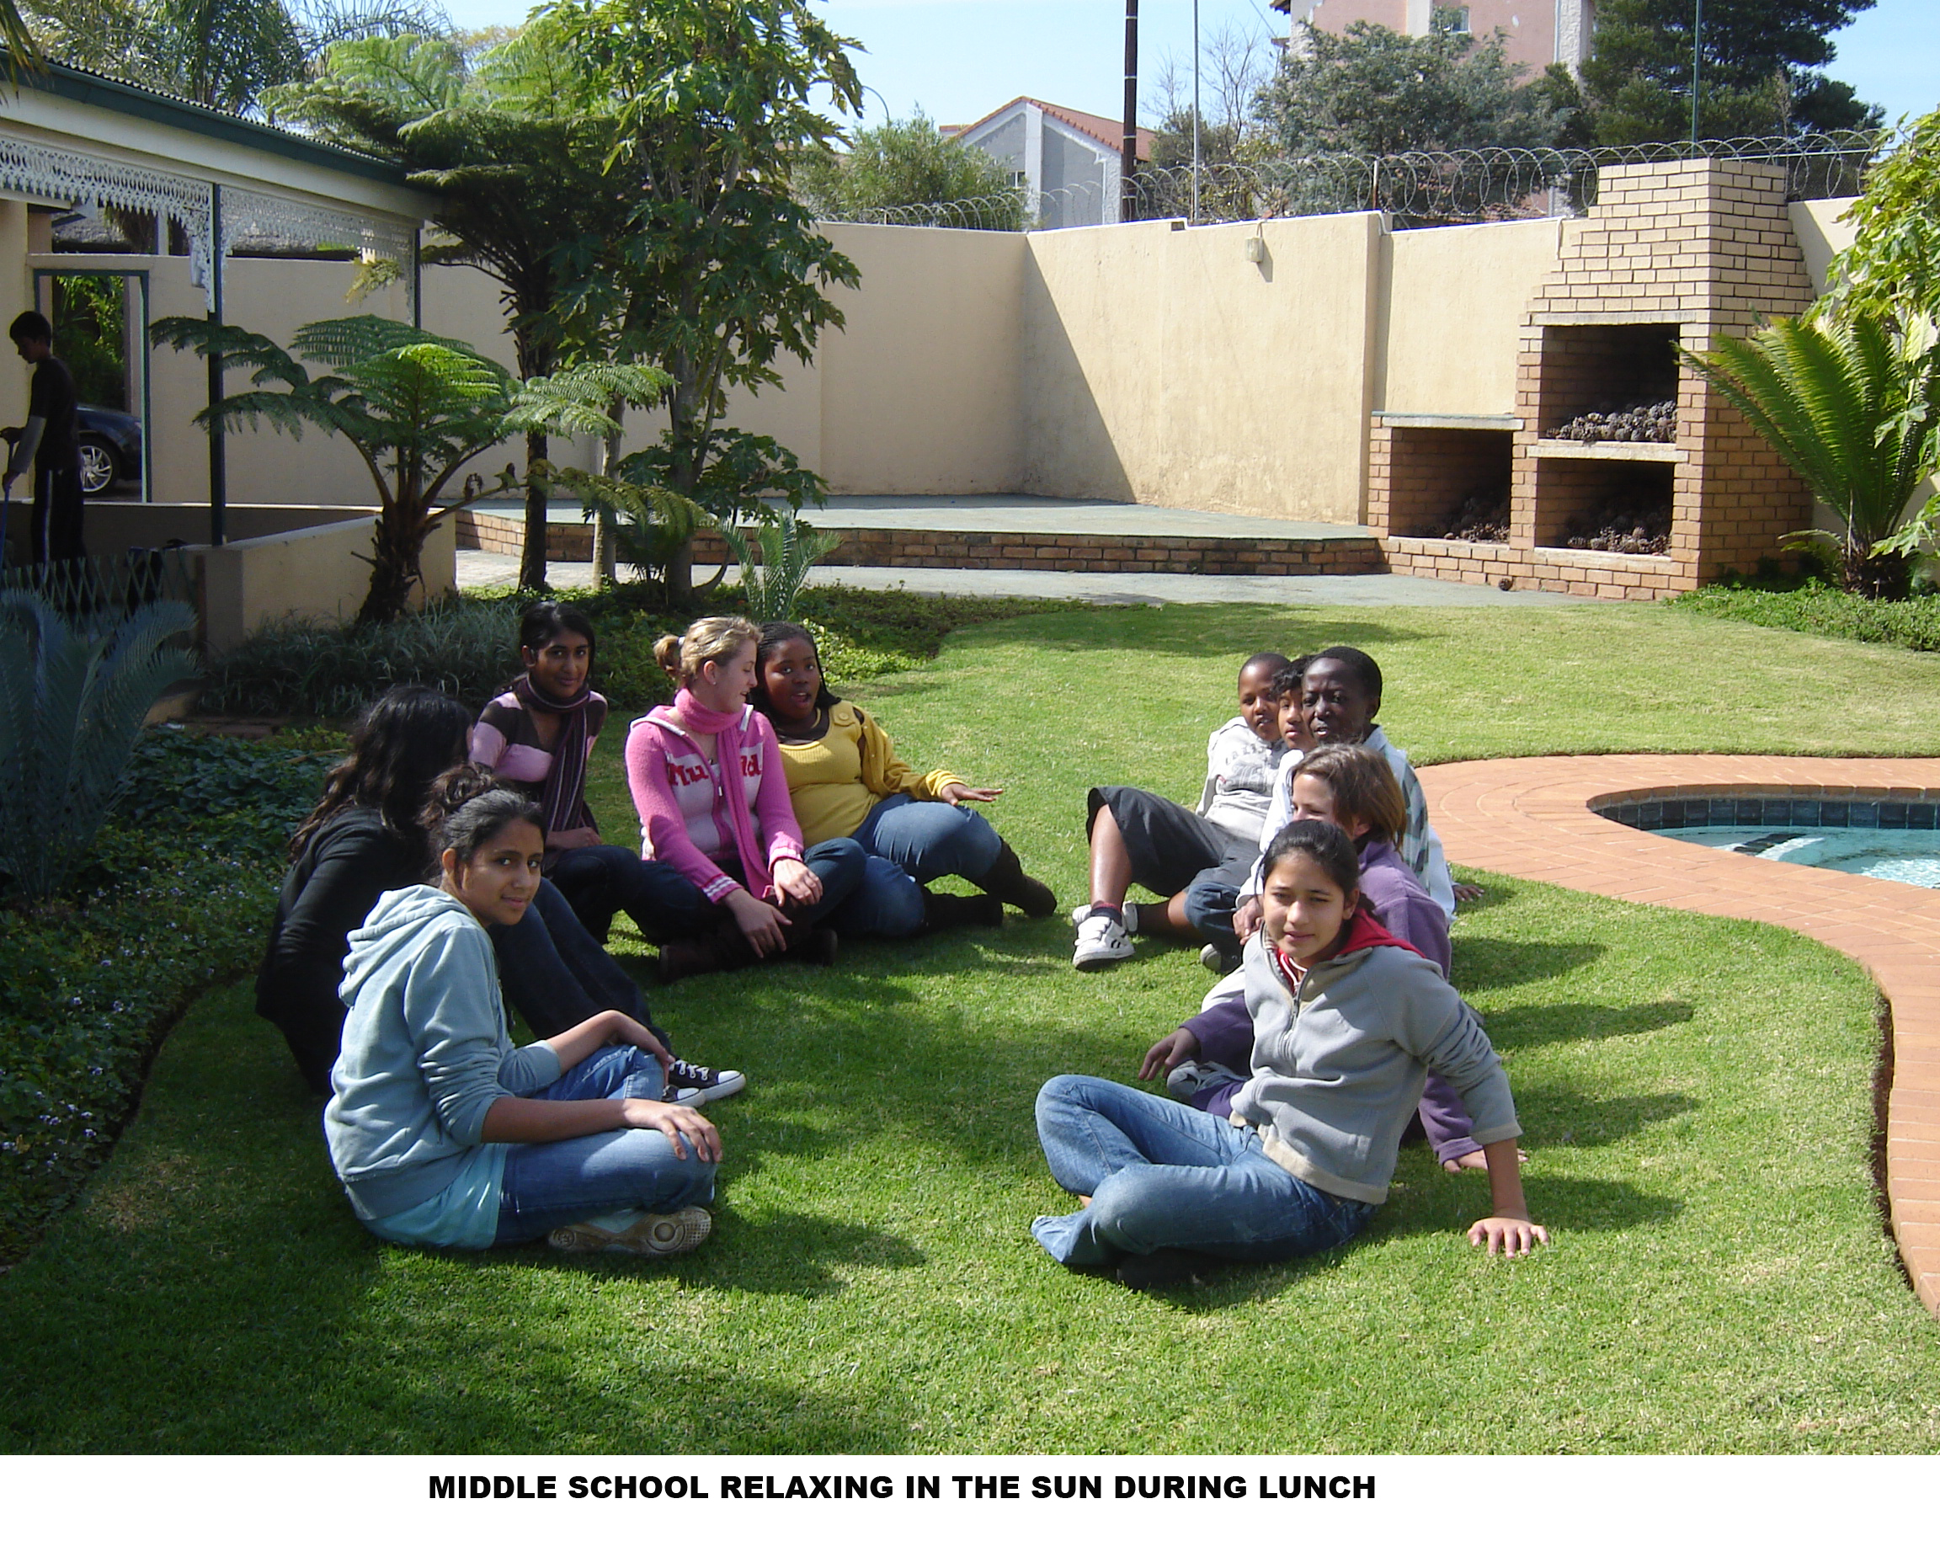

General Information

School starts | Pre-School, Primary & High School | 07:45
School closes | Pre-School | 12:30
School closes | Junior Primary | 13:00
School closes | Senior Primary | 13:30
School closes | Senior Primary | 13:00 Fridays
School closes | High School | 15:00
School closes |  | 13:00 Fridays

- Aftercare is available until 17:30.
- A cooked lunch can be ordered at a reasonable cost.
- Staff/pupil ratios:
Pre-School (3 to 6 years) 1:14
Primary school (Grade 1 to 6) 1:19
High school (Grade 7 to 12) 1:20
Aftercare 2:24

This is a guideline only.
- We have a three term year.
- No school uniform is prescribed. Children have to be dressed in an acceptable fashion.
- We encourage healthy eating and therefore have a strict food policy.
- A variety of extra-mural activities are offered.
- A five percent discount is granted on sibling’s fees and ten percent discount on fees paid in full before 31 January.
- Three month’s written notice is required in the event of a child leaving the school.

Extramural Activities

The following activities are presented by private coaches or tutors at private fees:

Pre-School:
Gym Kids Gymnastics Pottery Art
Playgolf Swimming Soccer Starz
Ballet Catrobatkidz
Tennis

Primary School:
Swimming Tennis Arts & Crafts
Go Dance Playgolf Pottery
Gym Kids Gymnastics Robotics Ballet
Soccer What’s Cooking

Application Process

We are selective when it comes to admitting students because the groups are small and we need to ensure that the appropriate atmosphere of learning and respect is maintained at all times. Only students with impeccable personal records will be considered. Our admissions process attempts to gather a picture of each applicant that will be as complete as possible.
It includes one or more classroom visits, interviews, assessment of the applicant, a review of the student’s academic record and the recommendations of teachers who have worked with the student and family.

For any potential pupil to be considered we must receive a completed application form accompanied by a copy of the most recent academic report as well as any therapy or relevant medical or professional reports and recommendations. We cannot proceed with the application until we receive your forms. Parents are strongly advised to submit the application form as early as possible because enrolment date is a factor in establishing priority in the event of a shortage of places. Young children may be placed on the waiting list. It is important that younger siblings are also enrolled as soon as possible.

Parents will be notified by written invitation of the dates and times that the child is required to attend an assessment. Prior to the assessment date the non- refundable application fee of R1500 must be made. Students are assessed for two consecutive mornings, giving sufficient time to ascertain whether or not the prospective student will thrive in a Montessori setting. Assessments take place in the Montessori environments.

Preschool children need to be fully toilet trained, three years of age and emotionally ready to follow basic verbal instructions and have a basic understanding of English. They will be required to demonstrate and display the potential to cope and adapt into the Montessori Pre-School environment.

Parents will be notified in writing of the results of their child’s application in the week following the assessment and are asked to notify the school either verbally or in writing of their intention to accept the place within the week. If your child is accepted, the Good Faith Deposit is payable within the time stipulated to secure their place in the school. Should the child be accepted, parents will also be invited for a parent interview. The interview is held with both parents/caregivers, the Village Montessori Enrolment Committee and the Principal. This is a platform for both sides to explore expectations and suitability. The Enrolment Committee considers a number of factors but the key considerations are the suitability of the child to the Montessori environment, level of family commitment to the Montessori Method, welfare of the school and smooth transition for the child.

Family Commitment

All primary caregivers should attend a parent interview as Montessori education is most effective when a child’s caregivers understand and co-operate with the long-term programme.
Parents and caregivers need to show understanding of the Montessori philosophy of teaching and fully support its methods. They need to agree to support the VMS staff. Parents and caregivers need to be willing participants and fully support all initiatives of the school in fundraising ventures, working days, parent education evenings, equipment making and social events. We are very happy for parents to indicate their own particular skills and preference for areas they would like to assist with.

SCHOOL CALENDAR 2019

TERM 1

School Opens: Wednesday 16 January
Mid-term School Closes: Thursday 21 February
Mid-term School Opens: Tuesday 26 February
Public Holidays: Thursday 21 March Human Rights Day
School Holidays: Friday 22 March School Holiday
School Closes: Friday 12 April 11:00

TERM 2

School Opens: Tuesday 07 May
Public Holidays Monday 17 June Youth Day, 16 June
Mid-term School Closes: Friday 28 June
Mid-term School Opens: Monday 08 July
School Closes: Thursday 08 August 11:00

TERM 3

School Opens: Tuesday 10 September
School Holiday Monday 23 September
Public Holiday: Tuesday 24 September Heritage Day
Mid-term School Closes: Thursday 24 October
Mid-term School Opens Tuesday 29 October
School Closes: Friday 06 December 11:00

Please note:
NO HOLIDAY CARE AVAILABLE

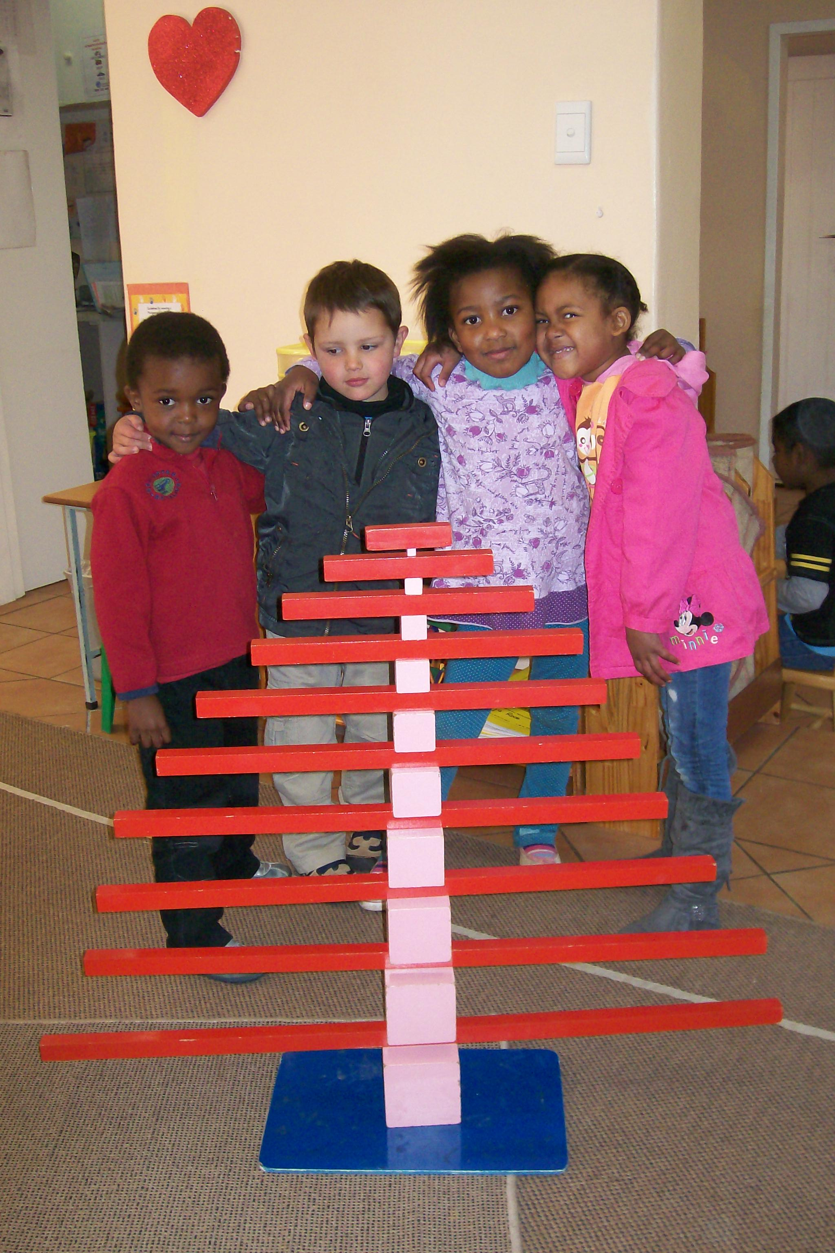

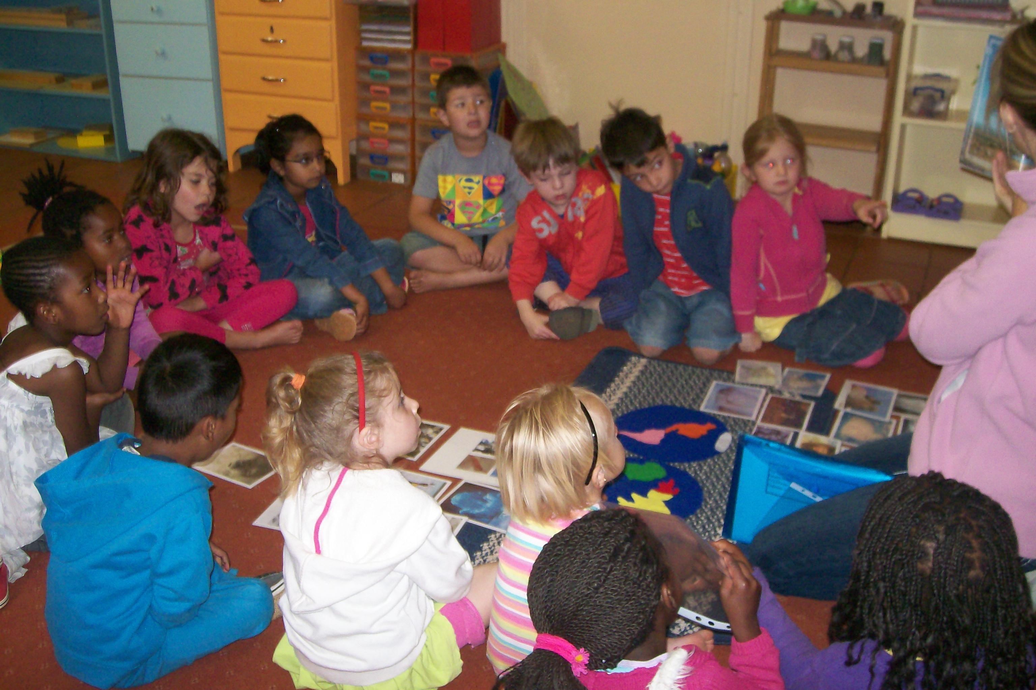

SCHOOL FEES 2019

PRE- SCHOOL:

Application fee: R 1 500.00 – Non Refundable
Good Faith Deposit: R12 000.00
Monthly fee: R 3 930.00 (X 11)
This fee includes: School fees up to 12:30, incl. Playball, Music, Outings, Snack & Lunch Aftercare fee per day: R40 from 12:45 up to 17:30 per child per day or any part thereof.
Sibling discount: 5% on monthly school fees
School fees paid upfront by 31 January for the year: 10% discount

JUNIOR PRIMARY (GR 1 – GR 3)

Application fee: R 1 500.00 – Non Refundable
Good Faith Deposit: R18 000.00
Monthly fee: R 6 000.00 (X 11)
This fee includes: School fees up to 13:00, incl. Chess, Music, Playball, Camp & Outings Aftercare fee per day: R40 from 13:15 up to 17:30 per child per day or any part thereof.
Meals per day: R15 per meal per child
Sibling discount: 5% on monthly school fees
School fees paid upfront by 31 January for the year: 10% discount

SENIOR PRIMARY (GR 4 – GR 6)

Application fee: R 1500.00 – Non Refundable
Good Faith Deposit: R20 000.00
Monthly fee: R 6 700.00 (X 11)
This fee includes: School fees up to 13:30, including Chess, Music, French, Computers, Playball, Camp and Outings.
Aftercare fee per day: R40 from 13:45 up to 17:30 per child per day or any part thereof.
Meals per day: R20 per meal per child
Sibling discount: 5% on monthly school fees
School fees paid upfront by 31 January for the year: 10% discount

SHORT ARTICLES ON MONTESSORI:

BASIC ELEMENTS OF THE MONTESSORI APPROACH

The Montessori Classroom
Montessori classrooms are bright, warm, and inviting. They are often filled with plants, animals, art, music, books, and interest centres filled with intriguing learning materials, fascinating mathematical models, maps, charts, fossils, historical artefacts, computers, scientific apparatus, perhaps a small natural science museum, and animals that the children are raising.

You will not find rows of desks in our classrooms, at Village Montessori School. Montessori learning environments are set up to facilitate student discussion and stimulate collaborative learning. One glance and it is clear that our children feel comfortable and at home.

Students will typically be found scattered around the classroom, working alone or with one or two others. They will tend to become so involved in their work that we cannot help but be tremendously impressed by the peaceful atmosphere.

It may take a moment to spot the teachers within the classroom. They will be found working with one or two children at a time, advising, presenting a new lesson, or quietly observing the class work.

In her research, Dr Montessori noted specific characteristics associated with the child's interests and abilities at each plane of development. She argued that a school carefully designed to meet the needs and interests of the child will work more effectively because it is consistent with basic principles of psychology. Rather than fight the laws of nature, Montessori suggested that we "follow the child" and allow our children to show us how to facilitate the development of their human potential.

The focus on the "whole child' led Montessori to develop a very different sort of school from the traditional adult-centred classroom. To emphasize this difference, she named her first school the "Casa dei Bambini" or the "Children's House".

There is something profound in her choice of words, for the Montessori classroom is not the domain of the adult in charge, but rather a carefully prepared environment designed to facilitate the development of the children's independence and sense of personal empowerment.

This is a true community of young children. They move freely within the rooms, selecting work that captures their interest, rather than passively participating in lessons and projects selected by the teachers.

In a very real sense, even the very youngest students at Village take care of their own child-sized environment. When they are hungry, they prepare their own snack and drink. They go to the bathroom without assistance. When something spills, they help each other carefully clean things up. Parents are often amazed to see small children in Montessori classrooms cut raw fruit and vegetables, sweep and dust, carry pitchers of water, and pour liquids with barely a drop spilled. These little ones normally go about their work so calmly and purposefully that it is clear to even the casual observer that this is their environment: The Children's House.

The Montessori classroom is commonly referred to as a prepared environment. This name reflects the care and attention that is given to creating a learning environment that will reinforce the children's independence and intellectual development.

Respect, Intelligence and Independence
We know that young children are full and complete individuals in their own right. They deserve to be treated with the full and sincere respect that we would extend to their parents. Respect breeds respect and create an atmosphere within which learning is tremendously facilitated.

Montessori schools believe very strongly that intelligence is not fixed at birth, nor is the human potential anywhere near as limited as it sometimes seems in traditional education.

Success in school is directly tied to the degree to which children believe that they are capable and independent human beings. If they knew the words, even very young children would ask: "Help me learn to do it for myself".

By allowing children to develop a meaningful degree of independence and self-discipline, Montessori sets a pattern for a lifetime of good work habits and a sense of responsibility. Students are taught to take pride in doing things for themselves carefully and well.

Montessori Teaches Children to Think, Collaborate and Discover
Our programme is designed to help each of our students discover and develop his or her unique talents and possibilities. We treat each as a unique individual learner. We know that no two students will learn at the same pace, nor will they necessarily learn best from the same teaching methods, and our goal is to be flexible and creative in addressing each student as a unique individual.

At VMS students and teachers learn to collaborate in the process of education rather than mindlessly compete. Our students discover their own innate abilities and develop a strong sense of independence, self-confidence, and self-discipline. In an atmosphere in which children learn at their own pace and compete only against themselves, they learn not to be afraid of making mistakes. They quickly find that few things in life come easily, and they can try again without fear of embarrassment.

One way of thinking about the difference between our approach and one that is more traditional is to consider that while learning the right answers may get our children through school, learning how to become life-long independent learners will take them anywhere! Our children are learning to think, observe, and reflect; not memorise and quickly forget.

Rather than present students with loads of right answers, their teachers ask the right questions and lead the children to discover the answers for themselves. Learning will become its own reward, and each success will fuel their desire to discover even more.

The Primary students are encouraged to do their own research, analyze what they have found, and come to their own conclusions. The teachers encourage our children to think for themselves and become actively engaged in the learning process.

Freedom of Movement and Independently Chosen Work
Montessori children are free to move about, working alone or with others at will. They may select any activity and work with it as long as they wish, so long as they do not disturb anyone or damage anything, and so long as they put it back where it belongs when they are finished.

The Integrated Montessori Curriculum
Classrooms at Village Montessori are organised into several curriculum areas, which include language arts (reading, literature, grammar, creative writing, spelling and handwriting), mathematics and geometry, everyday living skills, sensory awareness exercises and puzzles, geography, history, science, art, music, and movement. Each area is made up of one or more shelf units, cabinets, and display tables with a wide variety of materials on open display ready for use at the children select them.

VMS's curriculum is organised into a spiral of integrated studies, rather than a traditional model in which the curriculum is compartmentalised into separate subjects, with given topics considered only once at a specific grade level. In the early years, lessons are introduced simply and concretely and are reintroduced several times over succeeding years at increasing degrees of abstraction and complexity.

The course of study uses an integrated thematic approach that ties the separate disciplines of the curriculum together into studies of the physical universe, the world of nature, and the human experience.

Literature, the arts, history, social issues, political science, economics, science, and the study of technology all complement one another. This integrated approach is one of Montessori's great strengths. As an example, when our students study Africa in world history, they will also read African folk tales in world literature, create African masks and make African block print t-shirts in art, learn Swahili songs in music, and make hieroglyphic calendars in math, as well as study African animals in zoology.

Our mathematics curriculum follows a European model of unified mathematics through which students are introduced to concepts in algebra, geometry, mathematical logic, and statistics from the early years of their education, rather than waiting until high school as is normal in traditional education. The same is true in our science curriculum, weaving principles of physics, chemistry, the earth sciences, botany, and zoology together from the preschool years and up, with far greater emphasis on the sciences in general than is common in most elementary curriculums.

Typical Class Size
A typical Montessori class is made up from seventeen to thirty children, representing a three-year age span, taught by one or two certified Montessori teachers.

Parents often wonder if it would not be better to organize classes into smaller groups, but there is actually a great deal of research, thought, and successful experience behind this particular model. The key is to remember that in Montessori, the teacher is neither the centre of attention nor the sole source of instruction. The children are learning on their own by independent discovery and from each other, as well as through lessons presented by the teacher. This approach allows the children to explore and learn independently as much as possible. The stimulation of older children and the encouragement of their peers fuels the process, and all so often the best teacher of a four-year old is an older child rather than an adult. Children learn best from one another. We create classes of thirty to ensure that each child will have enough classmates of the same gender and age group, as well as the stimulation of the older children.

Montessori Classes Encompasses a Three-Year Age Span
Montessori classes are organised to encompass a two- or three-year age span, which allows younger students to experience the daily stimulation of older role models, who is turn blossom in the responsibilities of leadership. Students not only learn "with" each other, but "from" each other. We find that most often the best tutor is a fellow student who is just a bit older.

Some parents worry that having younger children in the same class as older ones will leave one group or the other short changed. They fear that the younger children will absorb the teacher's time and attention, or that the importance of covering the Grade 0 curriculum for the five-year-olds will prevent teachers from giving the three- and four-year-olds the emotional support and stimulation that they need. Both concerns are misguided.

Working in one class for two or three years allows students to develop a strong sense of community with their classmates and teachers. The age range also allows especially gifted children the stimulation of intellectual peers, without requiring that they skip a grade and feel emotionally out of place.

Each class is an essentially stable community, with only the oldest third moving on to the next level each year. At each level within a Montessori school, the curriculum and methods are logical and consistent extensions of what has come before.

How Can Montessori Teachers Meet the Need of So Many Different Children?
Montessori teachers play a different role from those played by traditionally trained educators. While the stern disciplinarians of the past may be an endangered species, many teachers are focused on maintaining order and on covering a pre-defined curriculum. Most see their role as dispensing facts and skills to complacent students.

The Montessori teacher's role is that of a facilitator and guide. He or she is usually not the centre of attention and will not normally spend much time working with the whole class at once. Her role centres around the preparation and organisation of appropriate learning materials to meet the needs and interests of each child in the class.

The Montessori teacher has four primary goals: to awaken our children's spirit and imagination, to encourage their normal desire for independence and high sense of self-esteem, to help them develop the kindness of self-discipline that will allow them to become full members of society, and to help them learn how to observe, question, and explore ideas independently. The Montessori teacher is a coach, mentor, and friend.

The teachers rarely present a lesson to more than one or two children at the same time and limit them to a quick, efficient presentation. The objective is to intrigue the children so that they will come back on their own to work with the materials. Lessons centre around clear and simple information that is necessary for the children to be able to do the work on their own: the name of the material, its place on the shelf, the ground rules for its use, and some of the possibilities inherent within it.

The teachers closely monitor their students' progress, keeping the level of challenge high. Because they come to know the children so well, Montessori teachers can often use their own interests to enrich the curriculum and provide alternate avenues for accomplishment and success.

The Montessori Materials - A Road from the Concrete to the Abstract
The basis of our approach is the simple observation that children learn most effectively through direct experience and process of investigation and discovery. In her studies of children's learning, Dr Montessori noted that most children do not learn by memorising what they hear from their teachers or read in a text, but rather from concrete and direct interaction with the environment. Asking a child to sit back and watch us perform a process of experiment is like asking a one-year -old not to put everything in his mouth. Children need to manipulate and explore everything that catches their interest. This led Montessori to emphasise the overriding importance of concrete learning apparatus and to the development of the Montessori materials for mathematics, sensory development, language, science, history, and geography.

The Montessori learning materials are not the method itself, but rather tools that we use to stimulate the child into logical thought and discovery. They are provocative and simple, each carefully designed to appeal to children at a given level of development.

Each material isolates and teaches one thing or is used to present one skill at a time as the child is ready. Montessori carefully analysed the skills and concepts involved in each subject and noted the sequence in which children most easily master them.

To facilitate the prepared order of the environment, the teacher arranges the materials on the shelf following their sequence in the curriculum flowchart. The materials are displayed on low open shelves that are easily accessible to even the youngest children. They are arranged to provide maximum eye appeal without clutter. Each has a specific place on the shelves, arranged from the upper-left-hand corner in sequence to the lower right. Materials are always arranged in sequence, from the most simple to the most complex, and from the most concrete to those that are most abstract.

Preparing Tomorrow's Innovative Thinkers Today
In a world of rapid change and new discoveries, we can only guess at the skills our children will need to succeed in the 21st century. Now, more than ever, the essential lesson is learning how to learn.

The most important years in our children's education are not high school and college, but, instead, their first twelve years of life. This is when their character and values, self-image, basic skills and knowledge, and appreciation for culture and the arts are formed.

Village Montessori School offers our children a world-class education, along with an education of the heart that nurtures their self-confidence, personal creativity, and entrepreneurial spirit.

It offers them the most challenging academic programme that they can handle in a course of study that includes creative writing, unified mathematics, geometry, pre-algebra, history, geography, economics, philosophy and ethics, computers, botany and zoology, the physical sciences, foreign language study, art, music, and physical education.

We can see our children as they truly come to love learning and begin to discover their true potential as young men and women. Granted, this lies beyond the scope of traditional education, but then VMS has set out to become a rather unusual school. As families, you come to schools like VMS to give your children outstanding preparation for tertiary education and life.

------Xxx-------

The following is an excerpt from a discussion on the Montessori Online discussion group. It is an answer from Tim Seldin, President of The Montessori Foundation and Chair of The International Montessori Council to a question from a parent who wanted to know how you know your family will fit into Montessori.

The selection of a Montessori School comes down to a matter of personal preference. If you visit a school and find yourself in love with the look and feel of the school’s atmosphere, and if you sense that your child is comfortable with the school’s atmosphere, then that school is more likely to be a good fit than one that leaves you confused and uncertain.

They do it with the best intentions, but it should be common sense that children who are educated in one consistent approach, and who grow up within one school community, tend to be more grounded and tend to get more long-term value from their school experience than children who have had to adjust to several different schools.

Parents who are comfortable with Montessori tend to agree with the following basic ideas about children’s learning:
- Intelligence is not rare among human beings. It is found in children at birth. With the right stimulation, it is possible to nurture the development of reasoning and problem solving skills in young children.
- The most important years of a child’s education are not high school and college, but the first six years of life. As a result, Montessori schools regard infant and early childhood education as the very foundation of everything that follows.
- It is critically important to allow children to develop a high degree of independence and autonomy.
- Academic competition and accountability are not effective ways to motivate students to become well educated. Students learn more effectively when school is seen as a safe, exciting, and joyful experience.
- A competitive classroom environment stifles creativity.
- There is a direct link between children’s sense of self-worth, empowerment, self-mastery, and their ability to learn and retain new skills and information.
- Education should be a transition from one level of independence, competency, and self-reliance to the next rather than a process of passing exams and completing assignments.
- Children are born curious, creative, and motivated to observe and learn things.
- Children learn in different ways and at different paces. The idea that those who learn quickly are more talented misses a basic truth about how children really learn.
- Children learn best through hands-on-experience, real-world application and problem solving.
- Teachers should serve as children’s mentors, and guides, rather than a taskmasters and disciplinarians. Students should be treated with profound respect, in partnership rather than with condescension, external control, and domination.
- Children are capable of making choices to guide their own learning.
- It is helpful for children to work together on school projects.
- School should be a joyful experience for children.
- The family assumes that their children will do well, and are fairly relaxed about academic issues. They want school to be exciting and fun, not demanding and stressful in the name of high standards.
- Parents want a school that will stimulate and encourage their child’s curiosity, creativity and imagination.
- The family would like to stay in Montessori at least for the elementary program, and perhaps beyond.
- The family would like to be involved with their children’s school. They look forward to this and want to participate in as many school activities and events as possible.

Parents who are comfortable with Montessori tend to disagree with statements such as:

- Academic competition prepares students for the real world.
- Children learn more when they are pushed.
- Testing helps to insure accountability for children, teachers and schools.
- Teachers must maintain strict discipline in the classroom.
- School is basically like army boot camp, a place to earn a degree. It is not supposed to be fun.
- Our family places very high priority on achievement. We have high expectations for our children, and are looking for a school that will provide them with a high level of challenge.
- We want to ensure that our children get into the best schools and colleges.
- Our family is able to attend some functions, but we have other commitments. It will depend on the event or function. (Montessori schools normally look for a high level of parent involvement).
- Our family plans to stay in Montessori for a year or so to give our children a good start, and then we plan to transfer them to the local public school (or another private or religious school).

Is Montessori right for your child?

Montessori is “right” for a wide range of personalities, temperaments and learning styles. Children who are consistently waiting for adult direction and those who have difficulty choosing and staying engaged in activities may have some initial difficulty transitioning into a Montessori class, but usually they learn to trust themselves and gradually strengthen their concentration as they meet with successful learning experiences and develop independence and concentration.

Children who are loud learn to use their “indoor voices”, and those who are messy learn to put away their work neatly. In most cases, parents and teachers work together between home and school to help them develop these new habits. One of the strengths of Montessori is the atmosphere of cooperation and respect, as children with a variety of personalities and learning styles find joy in learning.

Parents who are particularly concerned about high standards and achievement may find Montessori difficult to understand and support. While we all want the best for our children, Montessori really represents another way from the more conventional thinking found in most schools.

Montessori schools believe that children are normally born intelligent, curious and creative, and that all too often, parents and schools make the process of learning stressful rather than natural. We do not believe that most children need external or artificial structure and pressure to make them learn. We also believe that the current emphasis on testing and a state-established curriculum ignores common sense that the true nature of how children learn. The result is all too often students who are more stressed and apathetic about their educations than ever. Montessori children never seem to lose the joy of learning!

Montessori is “right” for families with a range of communication styles and learning expectations; however, families who are generally disorganized (arrive late in the morning, pick up children at varying times, and have difficulty reading and responding to school correspondence with consistency), may experience frustration in a Montessori setting.

The program is carefully structured to provide optimal learning opportunities for children. There is a place for everything, and everything is generally in its place!
Children from somewhat chaotic families often cling to this structure and find it very reassuring. But the transition from home to school and back home again can be difficult.

Montessori schools have various expectations regarding parental involvement. Research consistently demonstrates a strong connection between parental involvement and overall student achievement. Be aware of your school’s expectations and strive to be as involved as possible.

If, based on the evidence of your time spent visiting Montessori schools, you believe these basic fundamental principles are true, then Montessori is probably going to be a wonderful fit.

On the other hand if you find yourself concerned, then you may be more comfortable selecting a more conventional school for your child.

Tim Seldin
President, The Montessori Foundation
Chair, The International Montessori Council

